**CI/CD Pipeline Project**

**Problem statement**

**Create an end-to-end CI/CD pipeline in AWS platform using Jenkins as the orchestration tool, Github as the SCM, Maven as the Build tool, deploy in a docker instance and create a Docker image, Store the docker image in ECR, Achieve Kubernetes deployment using the ECR image. Build a sample java web app using maven.**

**Approach:**

**Requirements:**

**· CI/CD Pipeline system**

**· Git – local version control system**

**· Github-As Distributed Version control system**

**· Jenkins – Continuous Integration tool**

**· Maven-Java application build tool**

**· Docker-containerization**

**· Kubernetes-As Container Management tool**

**Step-1**

**- Create an separate EC2 instance for Github , Jenkins and Tomcat**

**- Setup Jenkins and install necessary plugins**

**- Setup and Configure maven by installing necessary plugins in the Jenkins**

**- Setup Tomcat server by changing necessary permissions in console**

**- Integrate Github, Maven , Tomcat server using Jenkins**

**- Build a new Maven project in Jenkins**

**- After that test the server by changing server content in github and check whether its updating in server**

**Developer Server**

Provide port 8080 to all the machines within the security group settings.

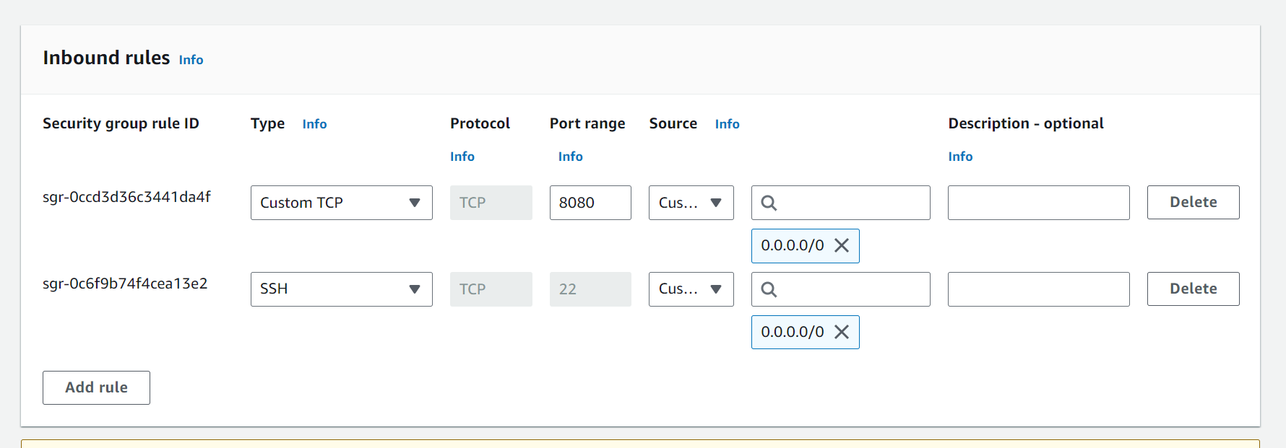

First install git

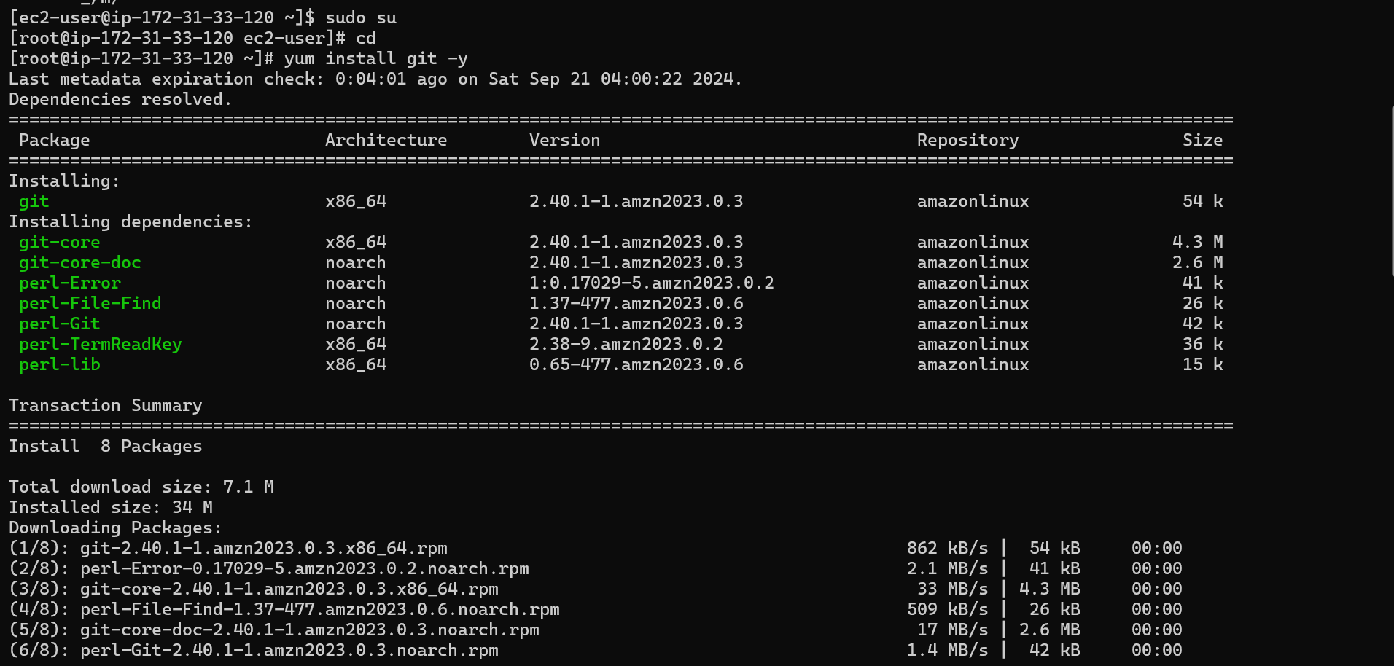

Change hostname to dev-server and do ssh-keygen

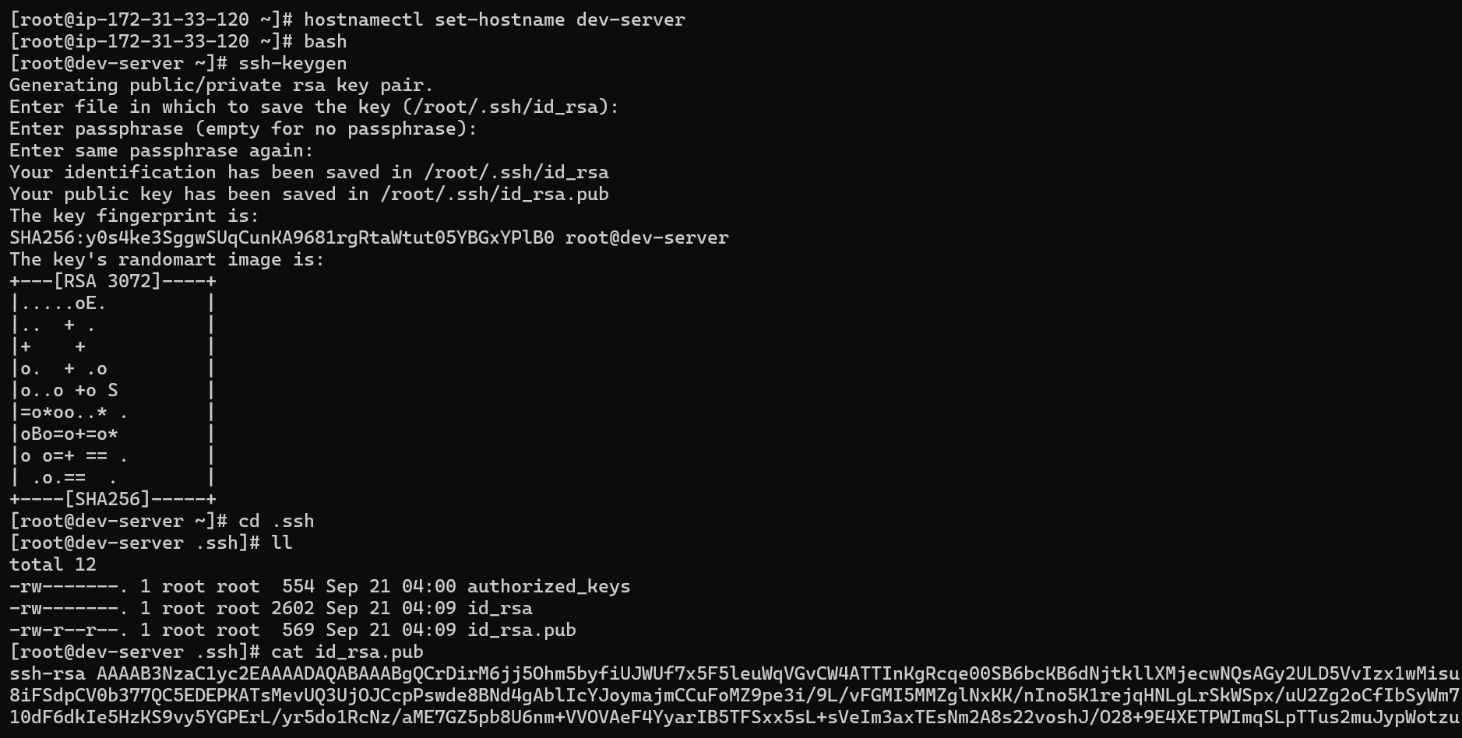

Paste it’s public key on git authentication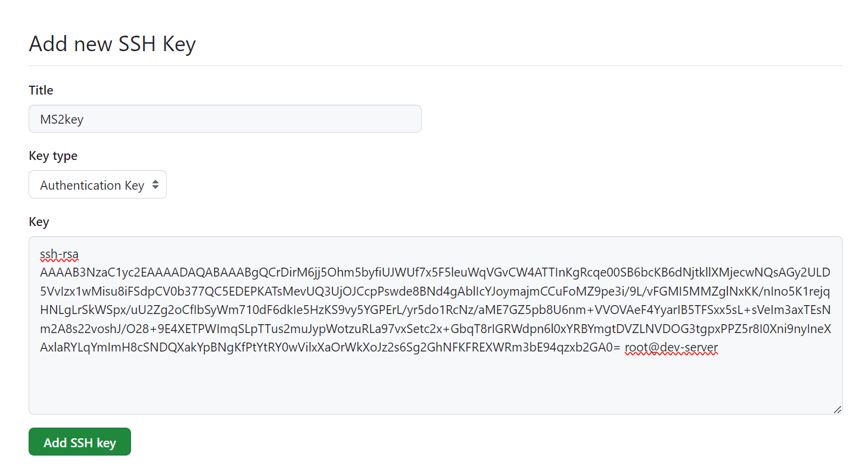

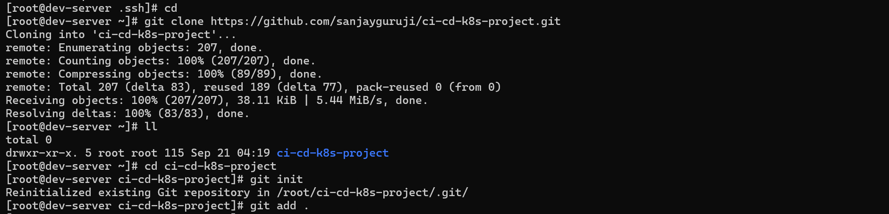

Add your name and email address in global configuration.



After that you will commit your project on main branch and then.

The command git remote remove origin will remove the remote repository named “origin” from your local Git repository. This means that your local repository will no longer be connected to the remote repository, and you won't be able to push your changes to or pull update from it.

And then

The command git remote add origin <REMOTE_URL> is used to add a remote repository to your local Git repository. Here’s what it does:

1. **Adds a Remote Repository**: It associates a remote URL with a name, typically origin. This name is an alias for the remote repository URL.
2. **Facilitates Collaboration**: By adding a remote, you can push and pull changes between your local repository and the remote repository.
3. **Default Naming**: The term origin is a convention used to refer to the main remote repository, usually the one you cloned from.

And Then

The command git branch -M main is used to **rename the current branch to “main”**. Here’s a breakdown of what it does:

* -M: This option stands for “move” and is used to rename the branch. The -M flag will force the rename even if a branch named “main” already exists.
* main: This is the new name for the branch.

So, if you are currently on a branch named “master” and you run git branch -M main, it will rename the “master” branch to “main”.

And then

The command git push origin main is used to upload the changes from your local repository to the remote repository. Here’s a breakdown of what each part of the command does:

* git push: This command is used to upload your local repository content to a remote repository.
* origin: This is the default name for the remote repository that you cloned your local repository from. It acts as a reference to that remote repository.
* main: This specifies the branch you want to push your changes to. In this case, it is the main branch, which is often the default branch in many repositories.

So, when you run git push origin main , you are pushing the commits from your local main branch to the main branch on the remote repository named origin.

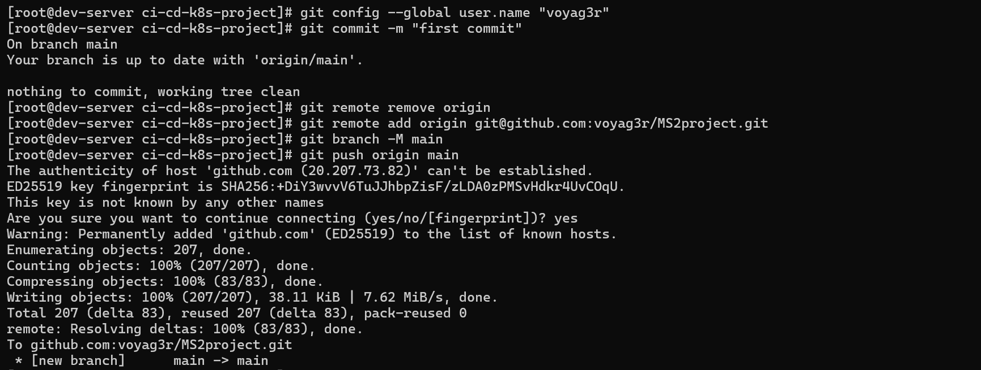

Check your repository on github now,

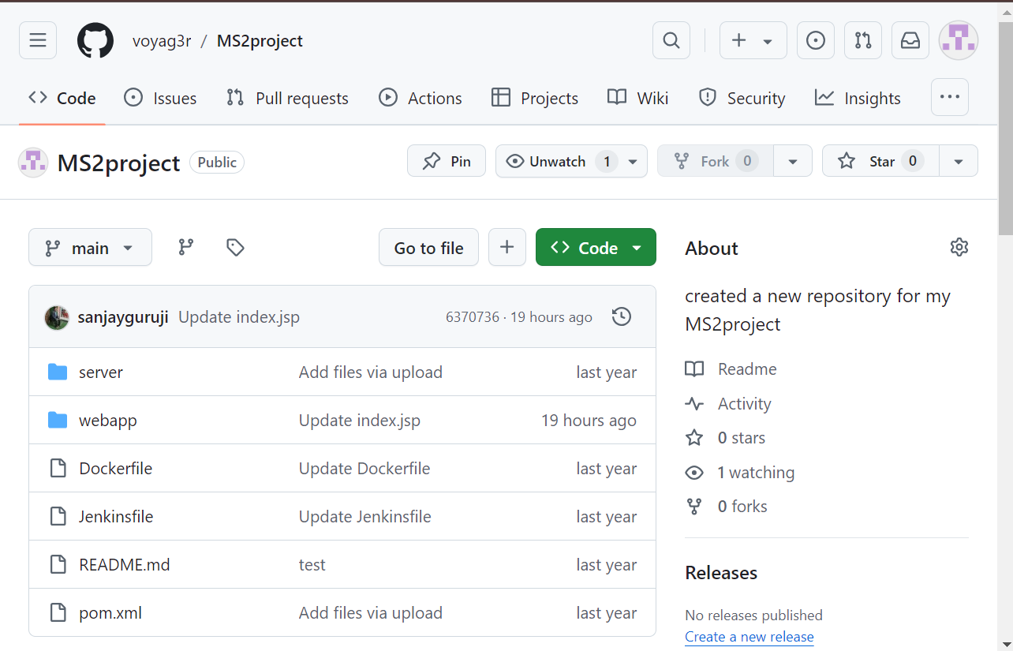

**Jenkins Server**

First connect to the newly created machine for Jenkins server and rename it to Jenkins-server.

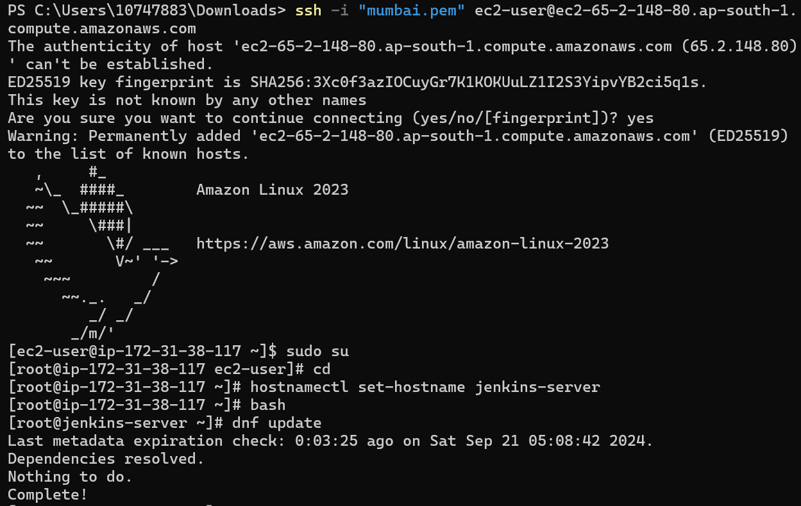

Now first install java on this machine so that we can install Jenkins.

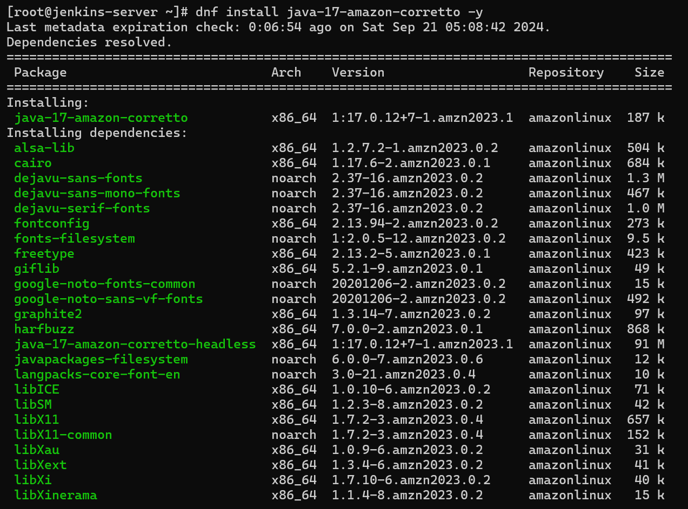

Now add the Jenkins repository to the local system.

Import a key file from the Jenkin-CI to enable installation of the package.

Finally, we can install Jenkins.

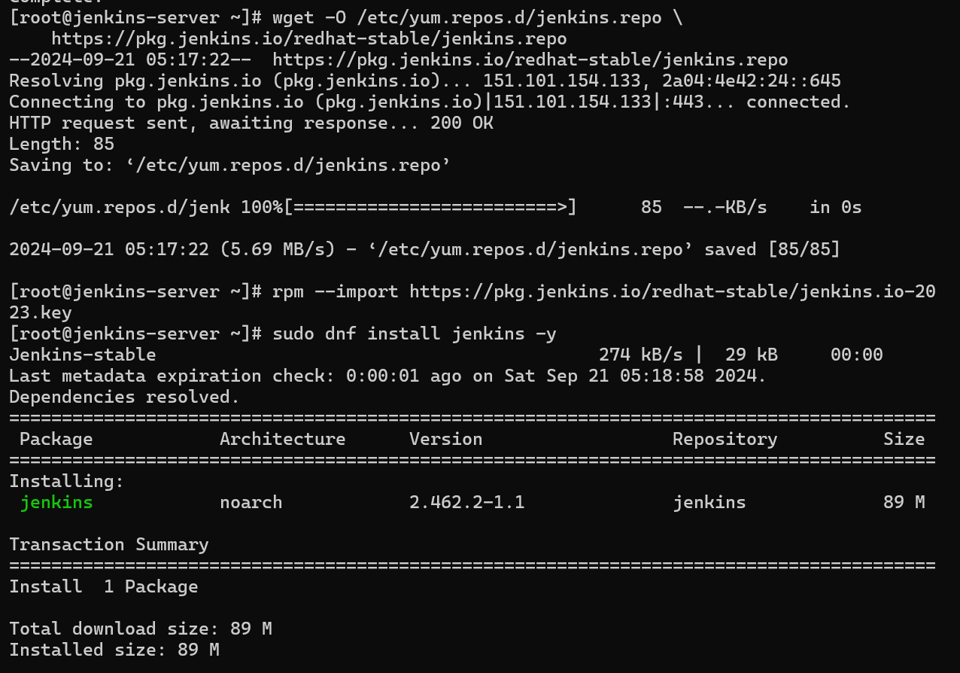

And finally, we can enable and start Jenkins.

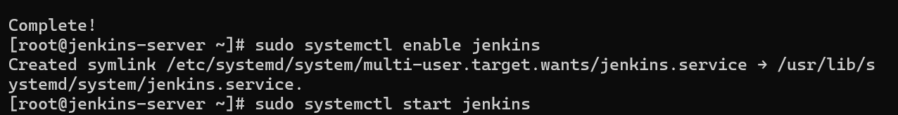

Now open your Jenkins on web with dns public ip.

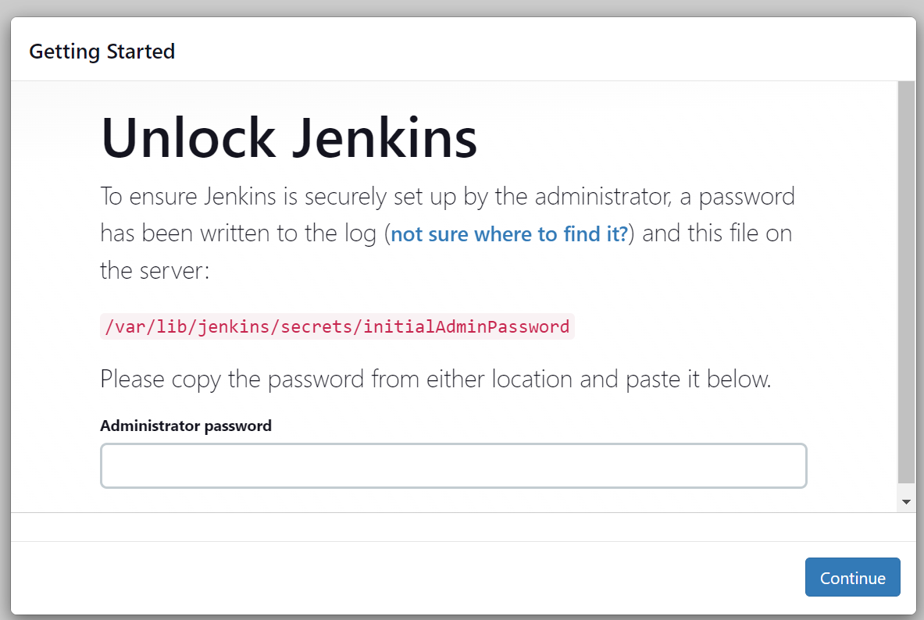

Do as what is mentioned above on the tab



And paste this password on the above Jenkins tab and finally install suggested plugins.

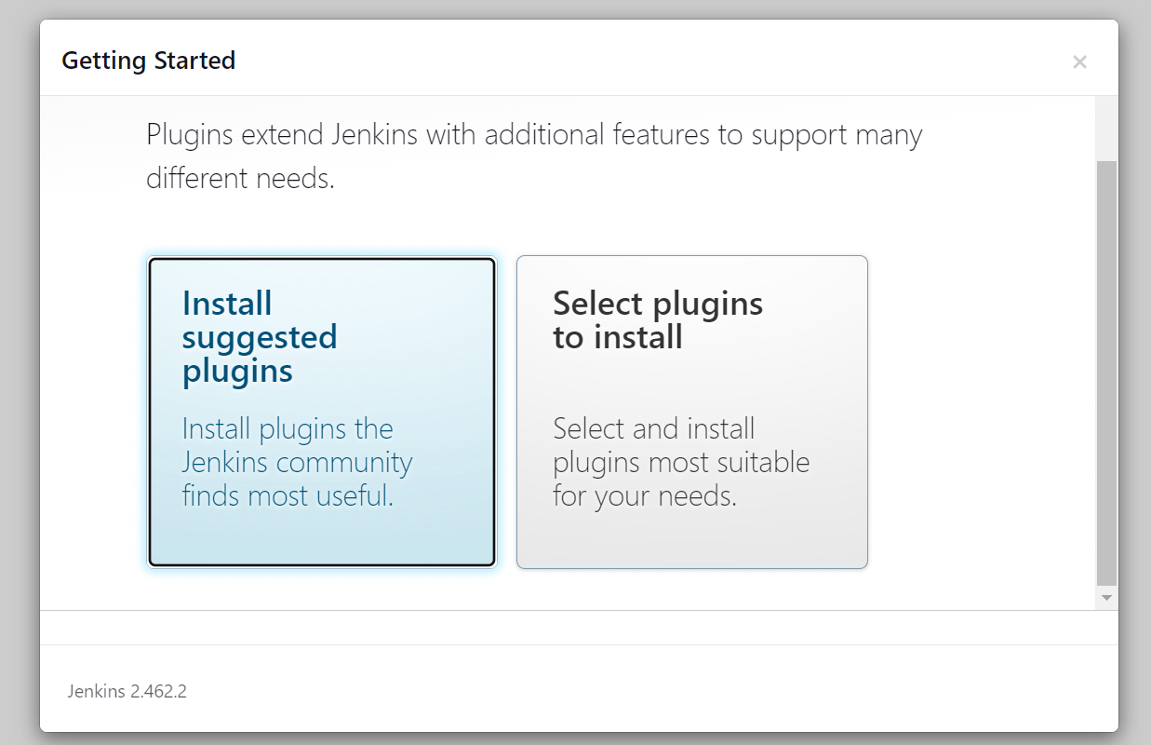

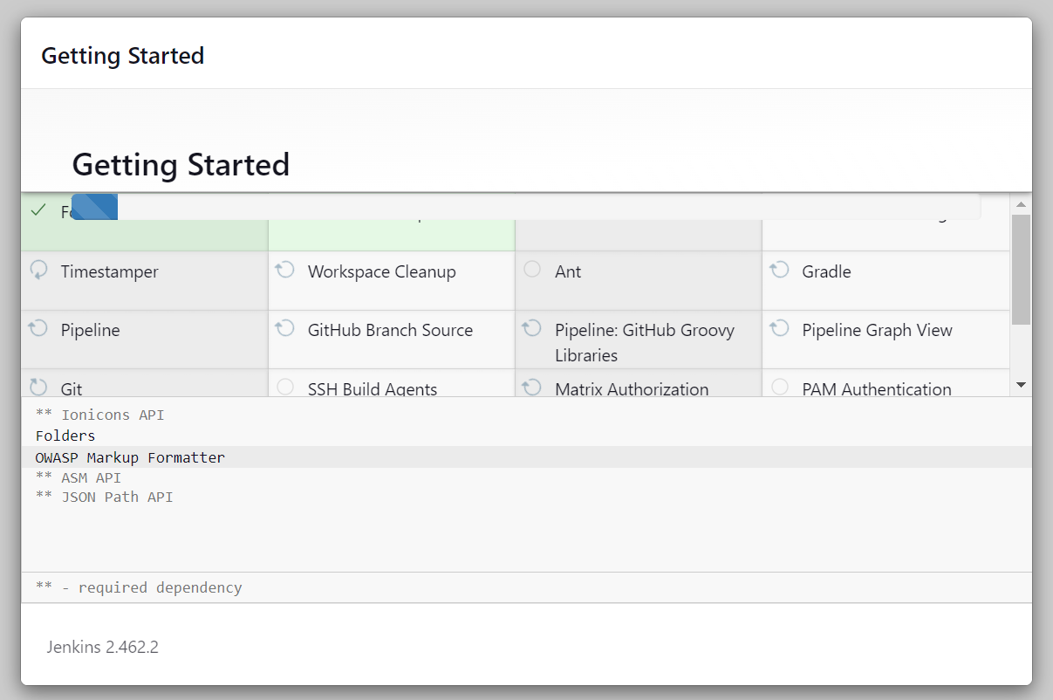

And now create admin user.

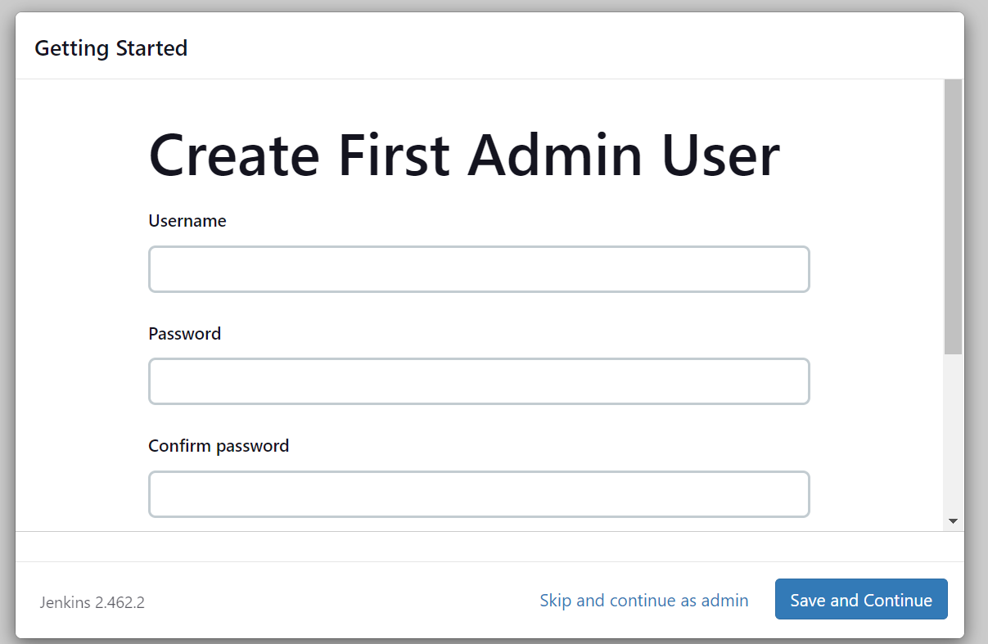

Save and continue

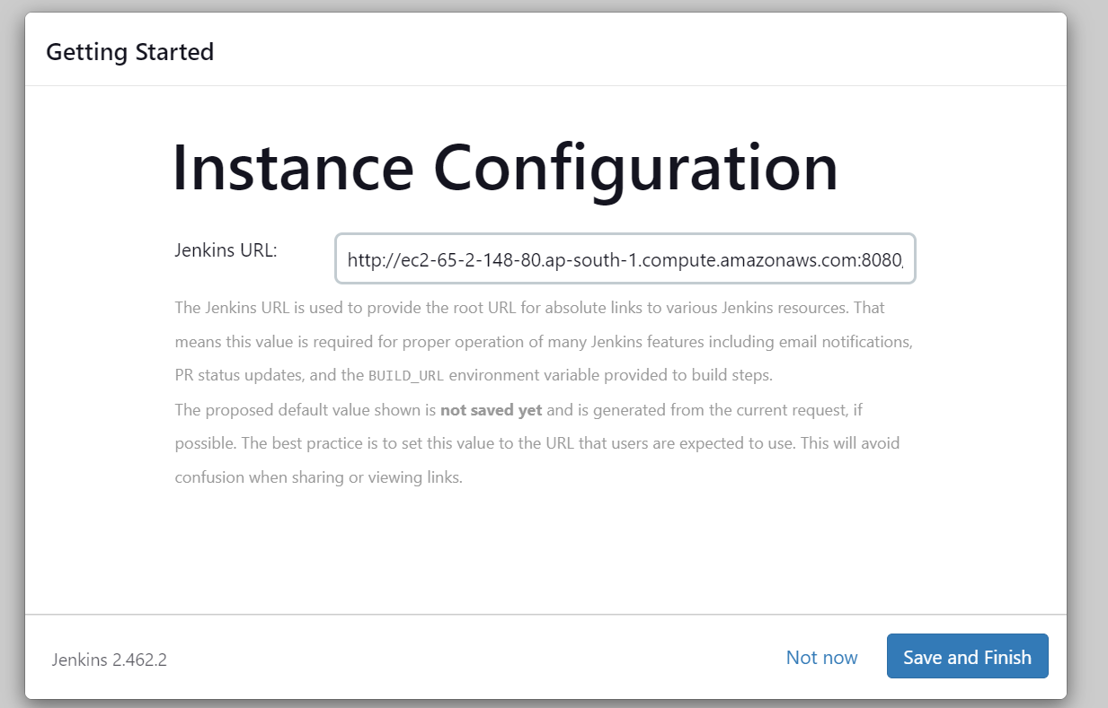

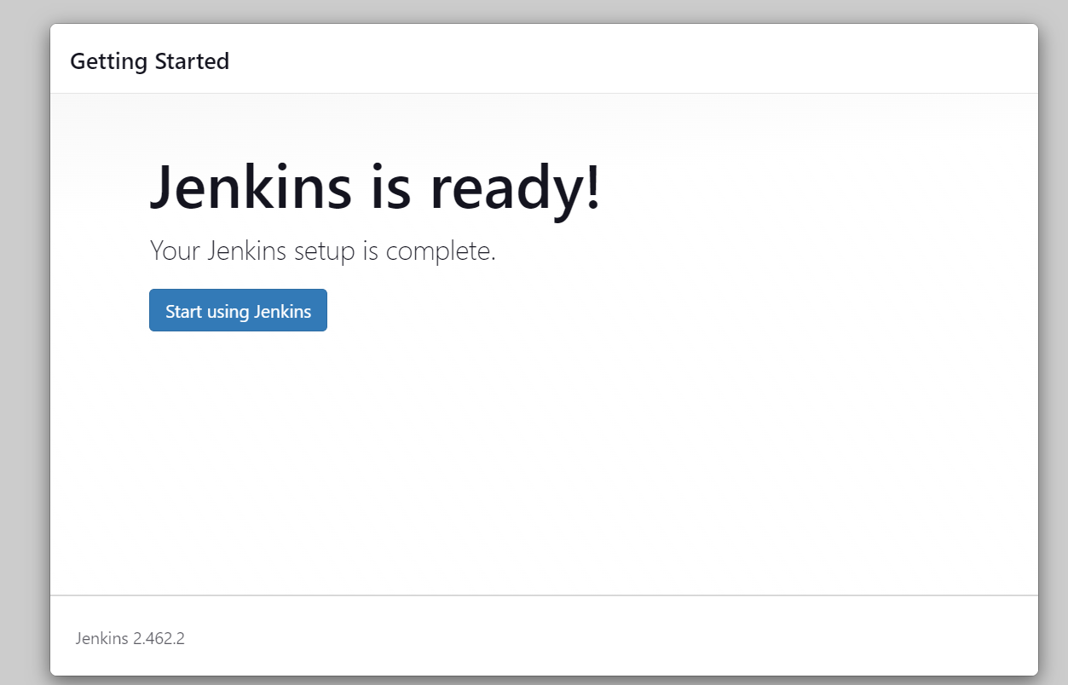

Finally we can see our Jenkins is configured.

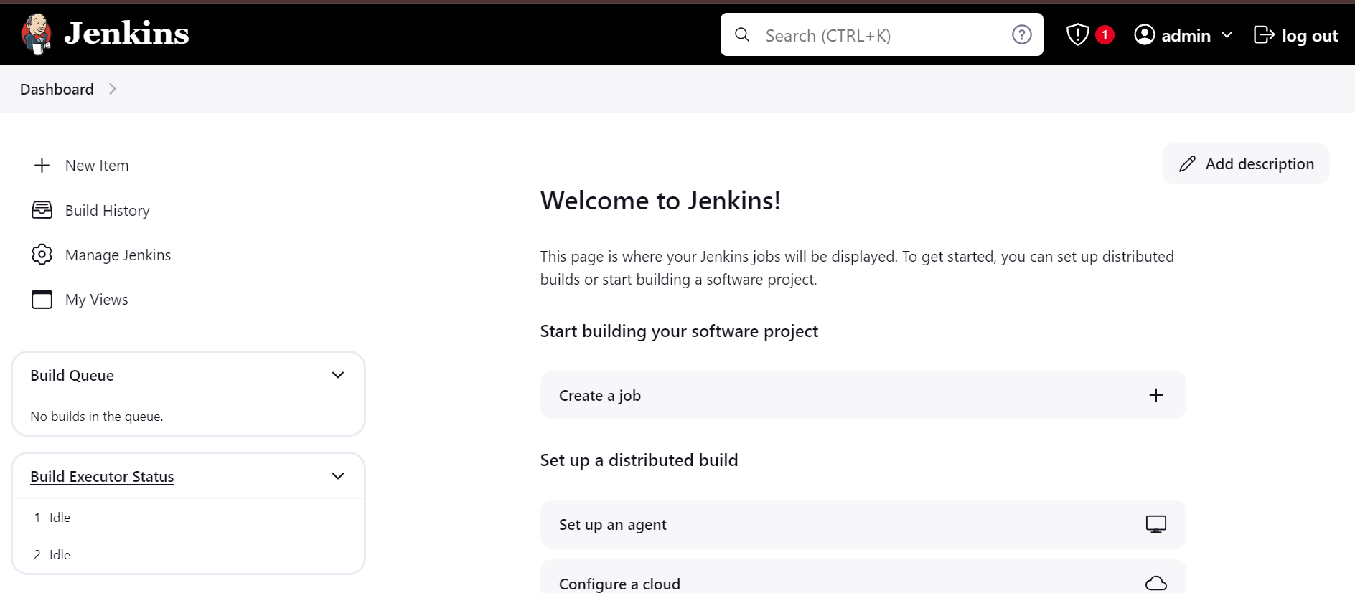

Now generate token

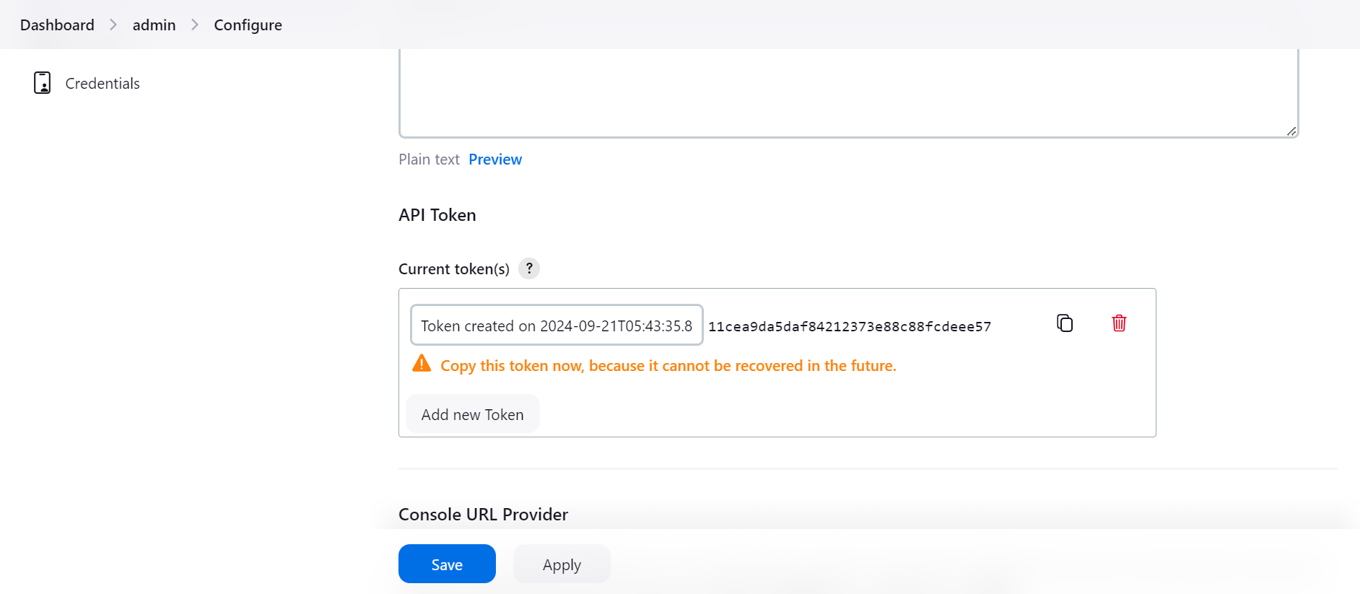

Now we will connect Jenkins to github with webhook for that we need to install git on Jenkins-server as well.

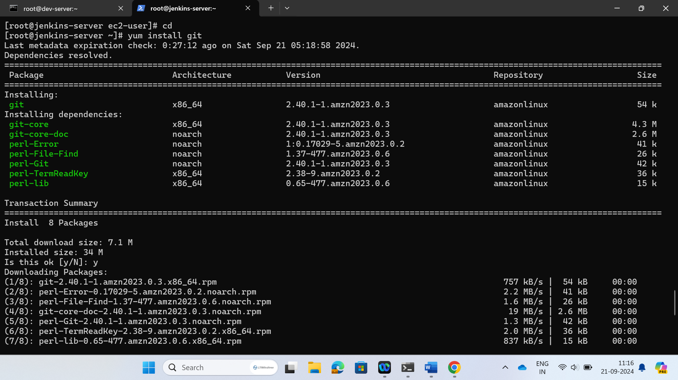

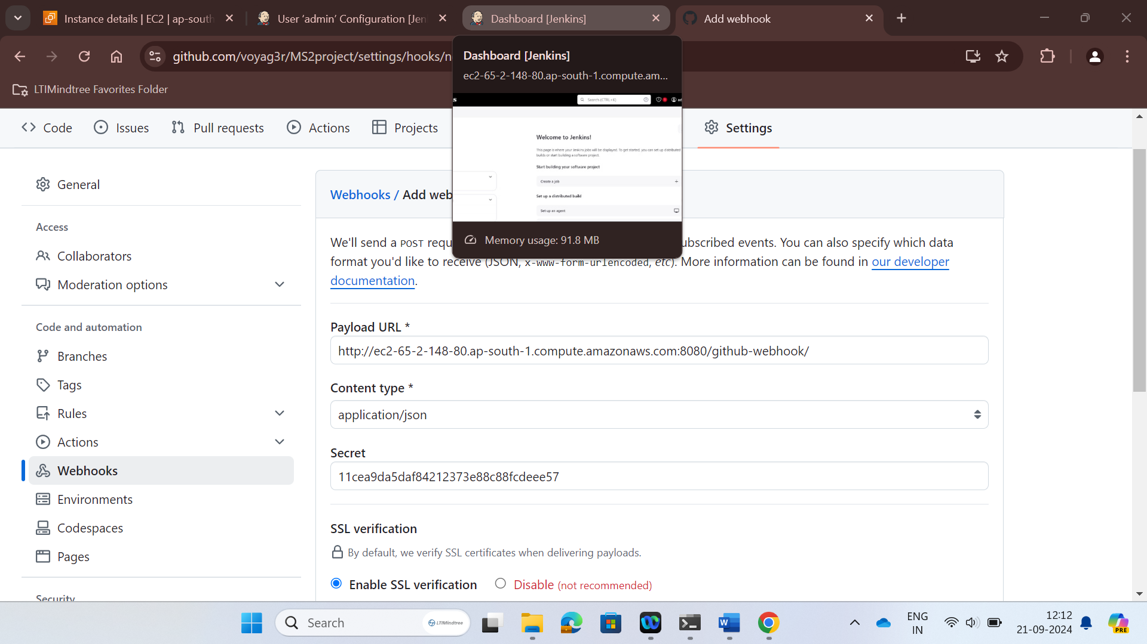

Now install maven in Jenkins server

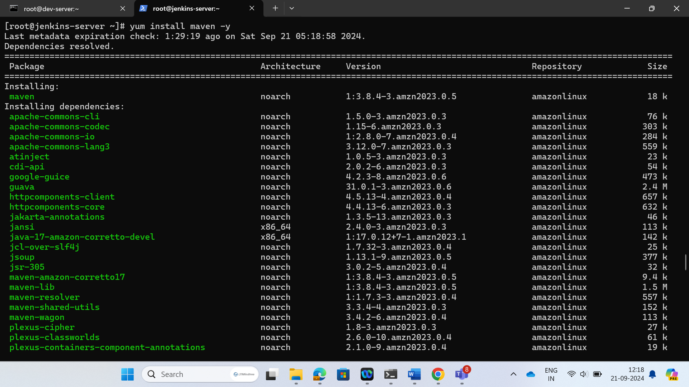

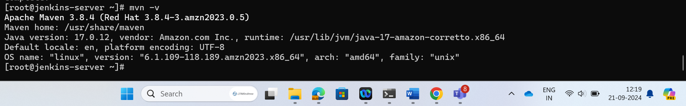

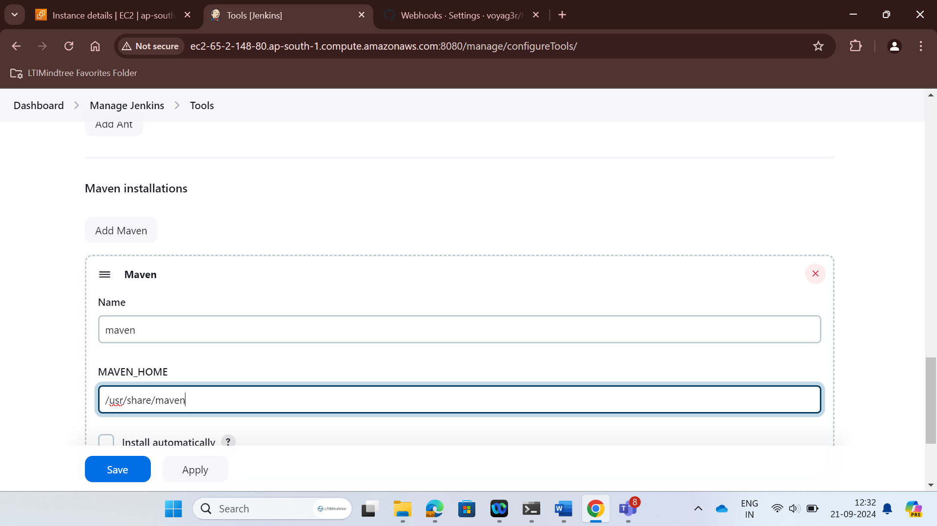

After all configuration we will build our git project and Console output is displayed here.

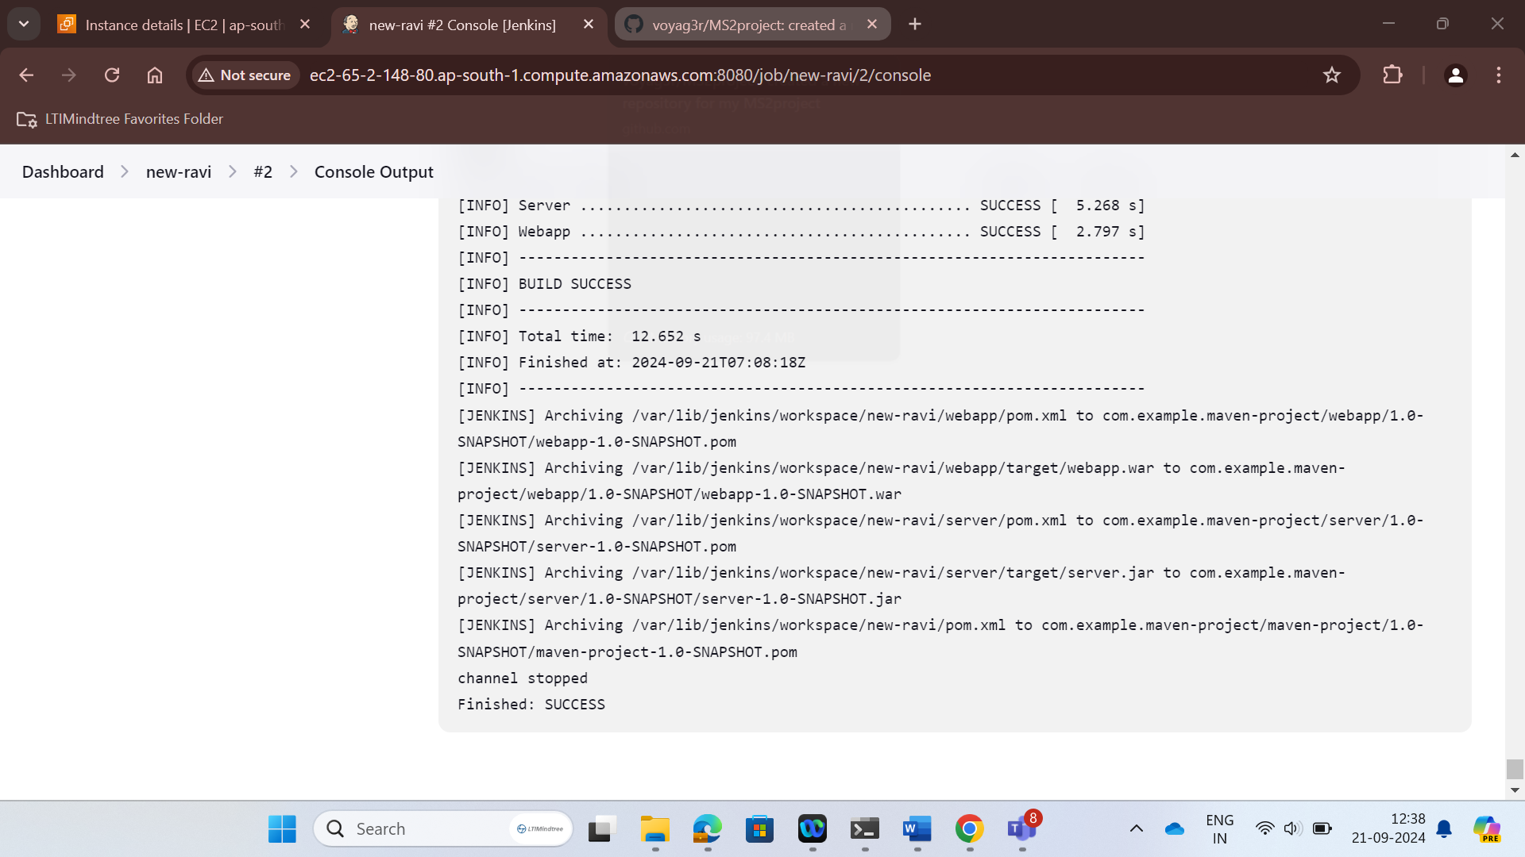

**Tomcat:**

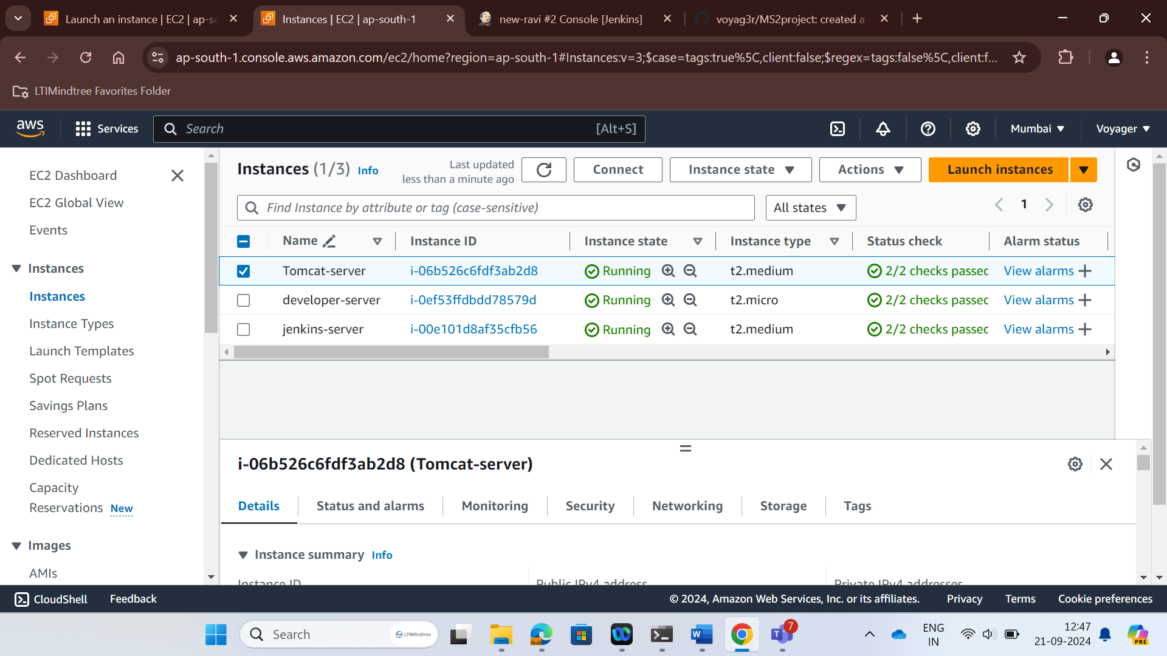

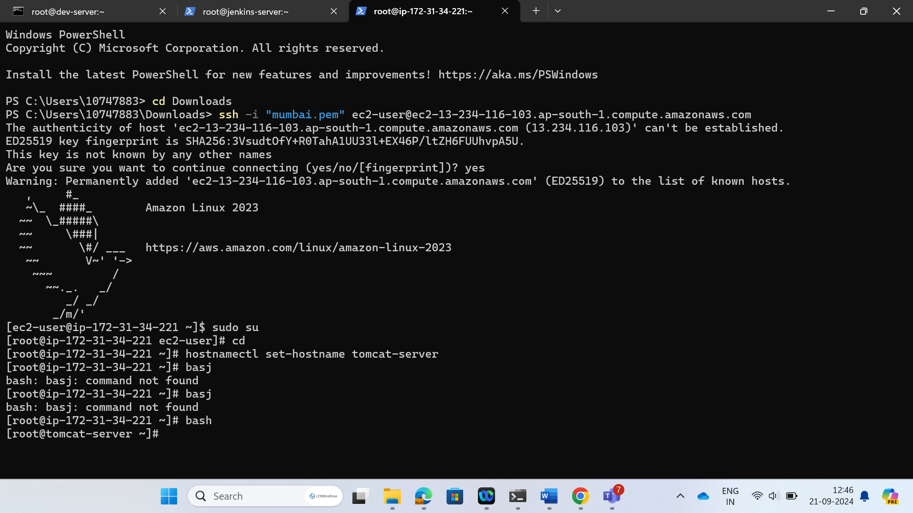

Install java

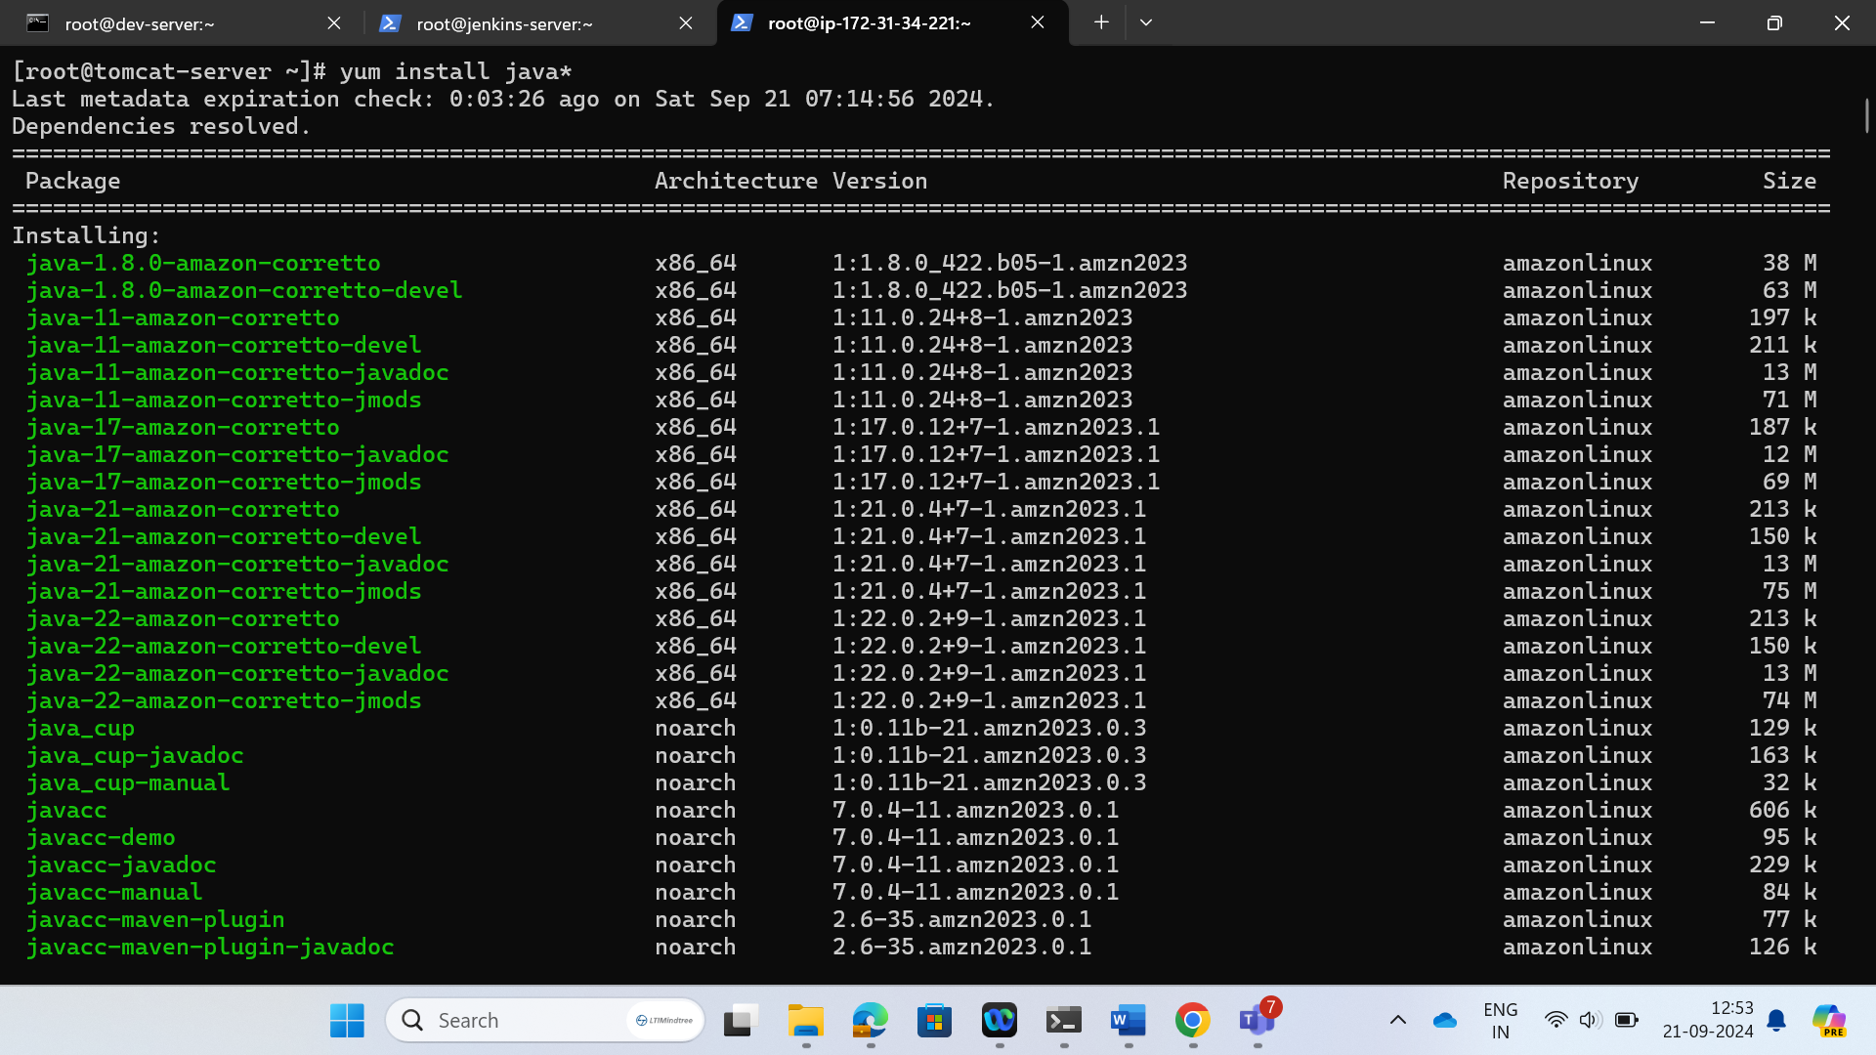

Now install tomcat

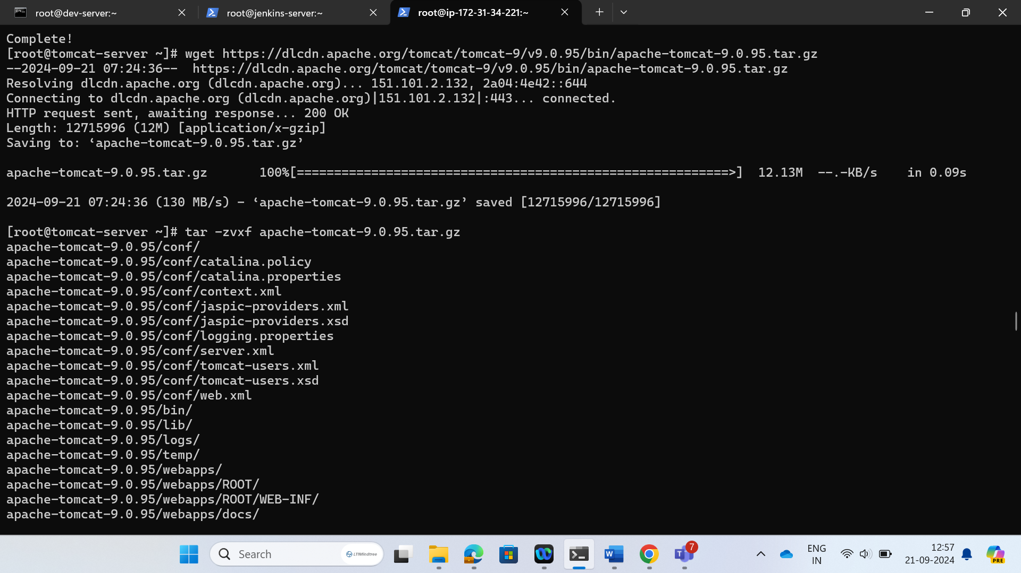

Unzip the apache tomcat folder. Enter in apache-tomcat folder. Open the bin file and f ind the path of all context.xml files.

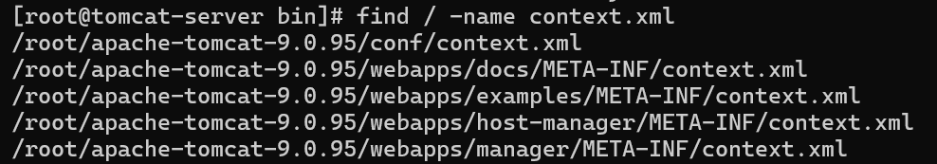

Change the last two files and comment out valve

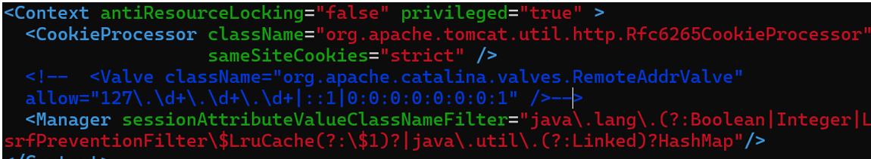

Open the conf/ tomcat-users.xml file and add users:

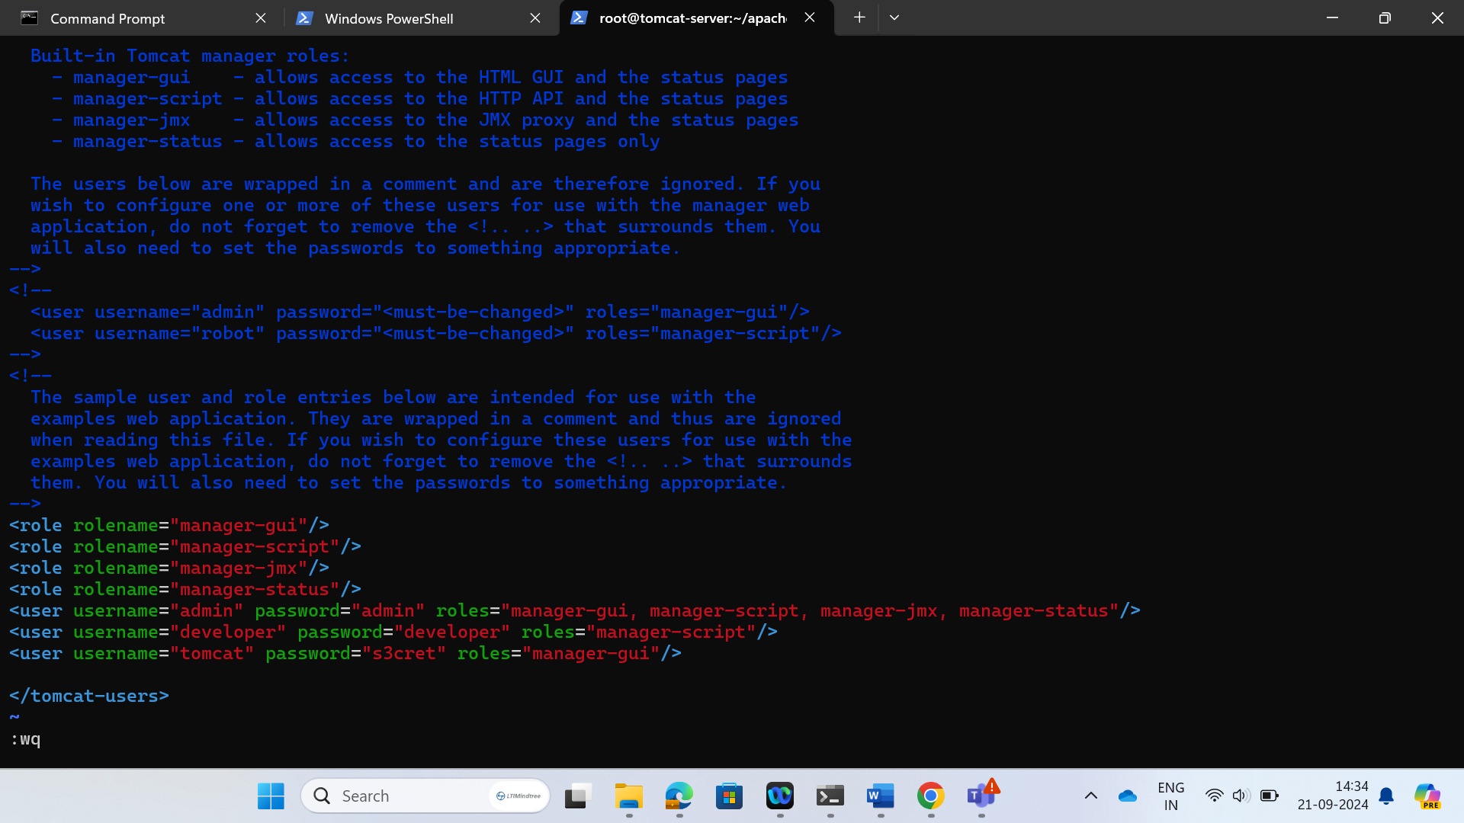

Start tomcat

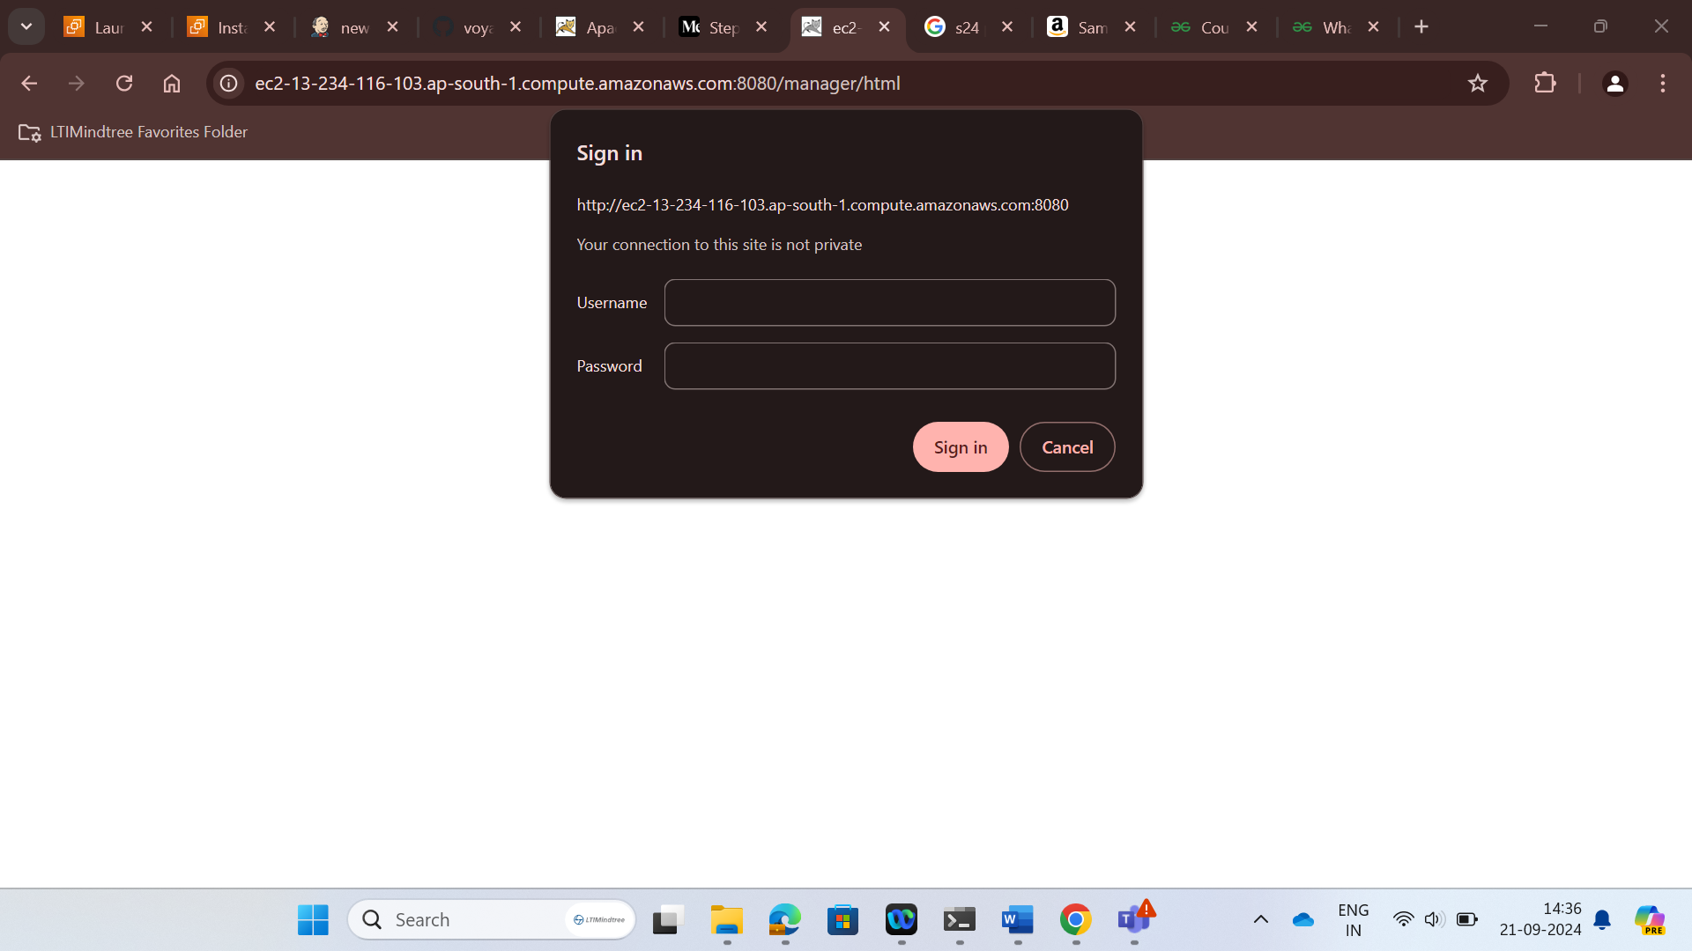

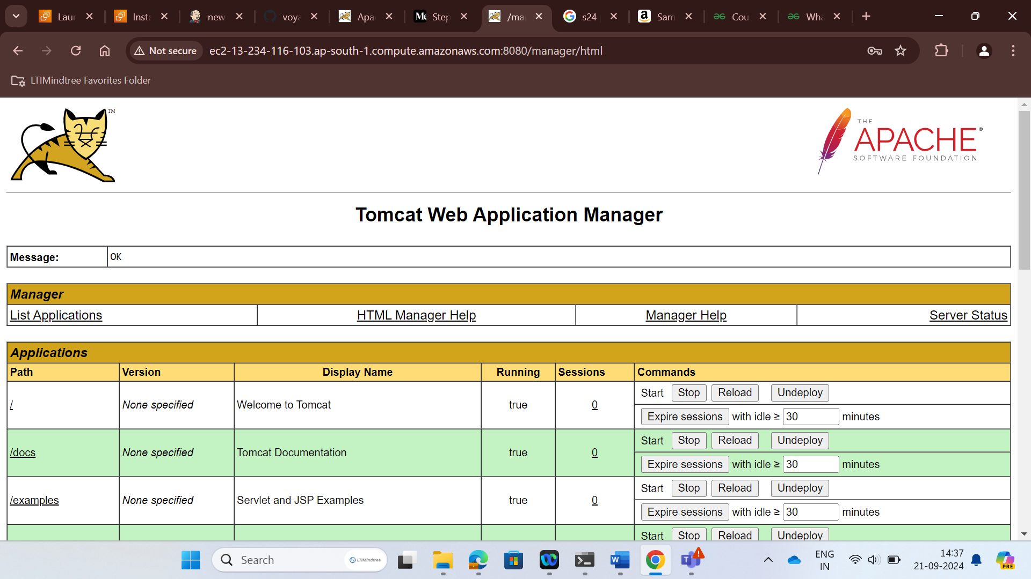

Now go to credentials

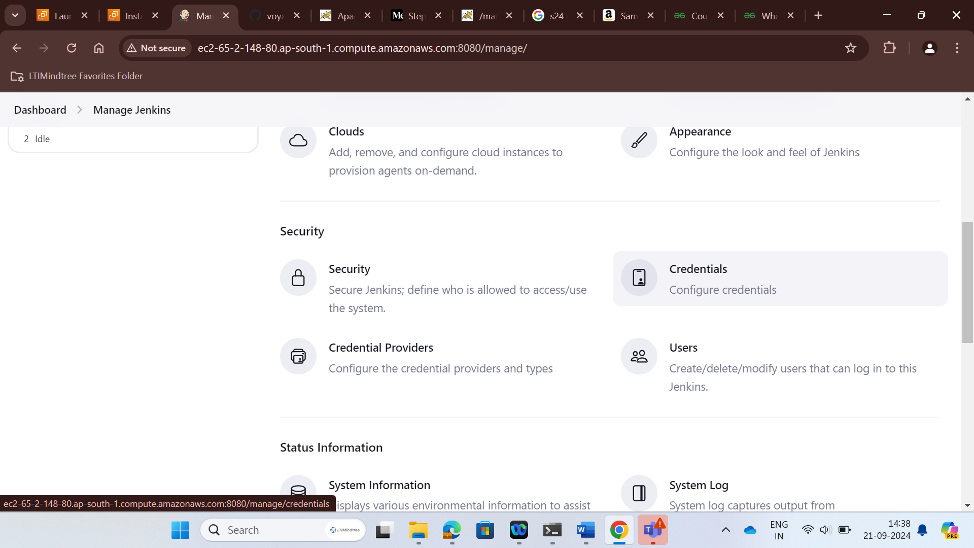

Then system > Global credential and then add credential

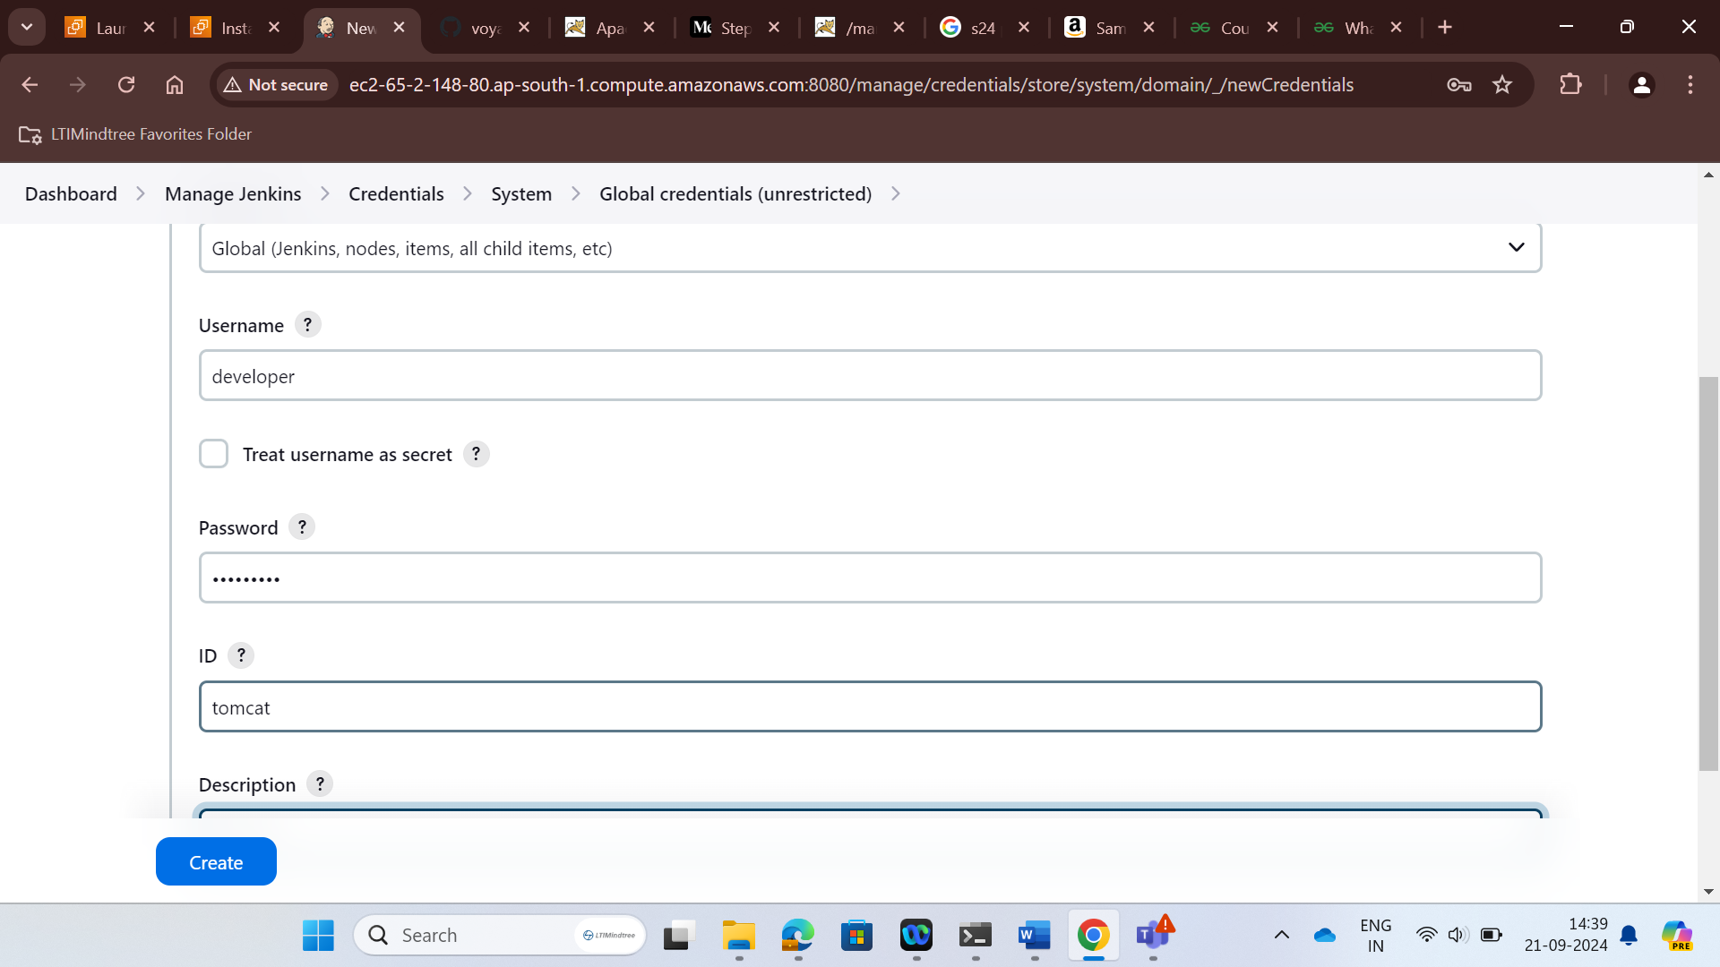

>Create new item

> type name

> select maven project

> add git repository link

> change branch to main

> Build trigger

> Go to add post built action

> deploy ear/war to a container

> Save and apply > Build now

And finally we can see the build is successful

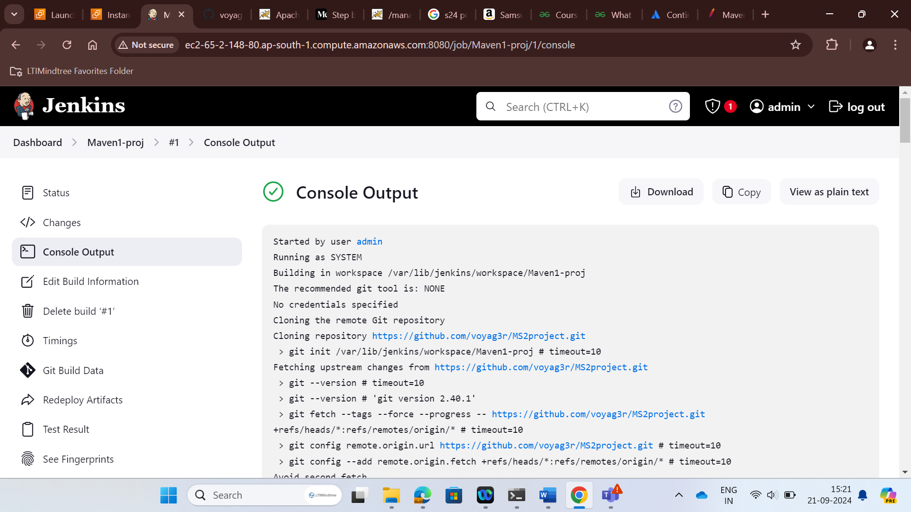

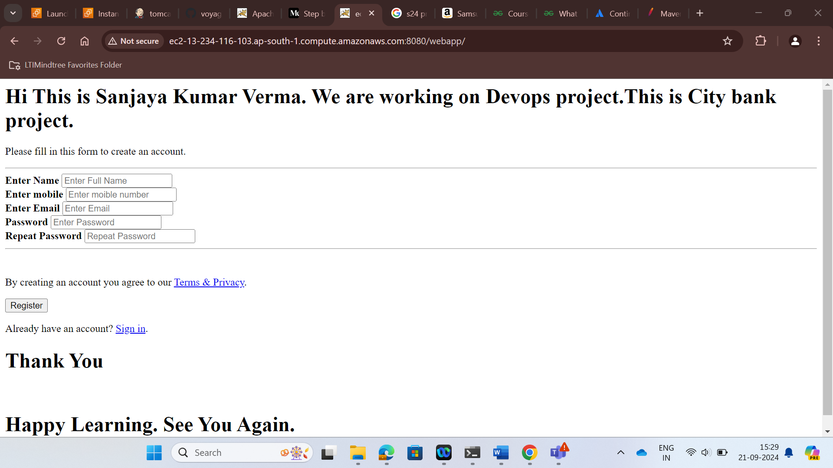

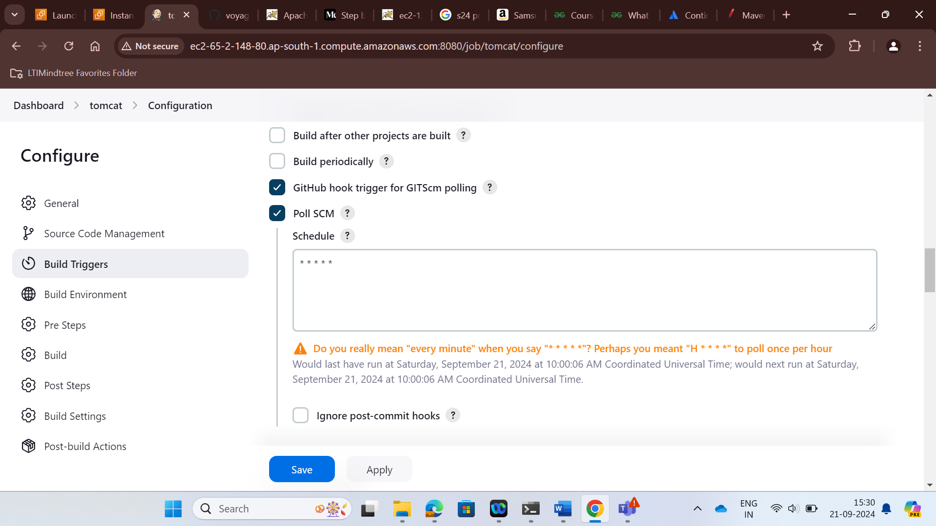

After updation we can see the results as well.

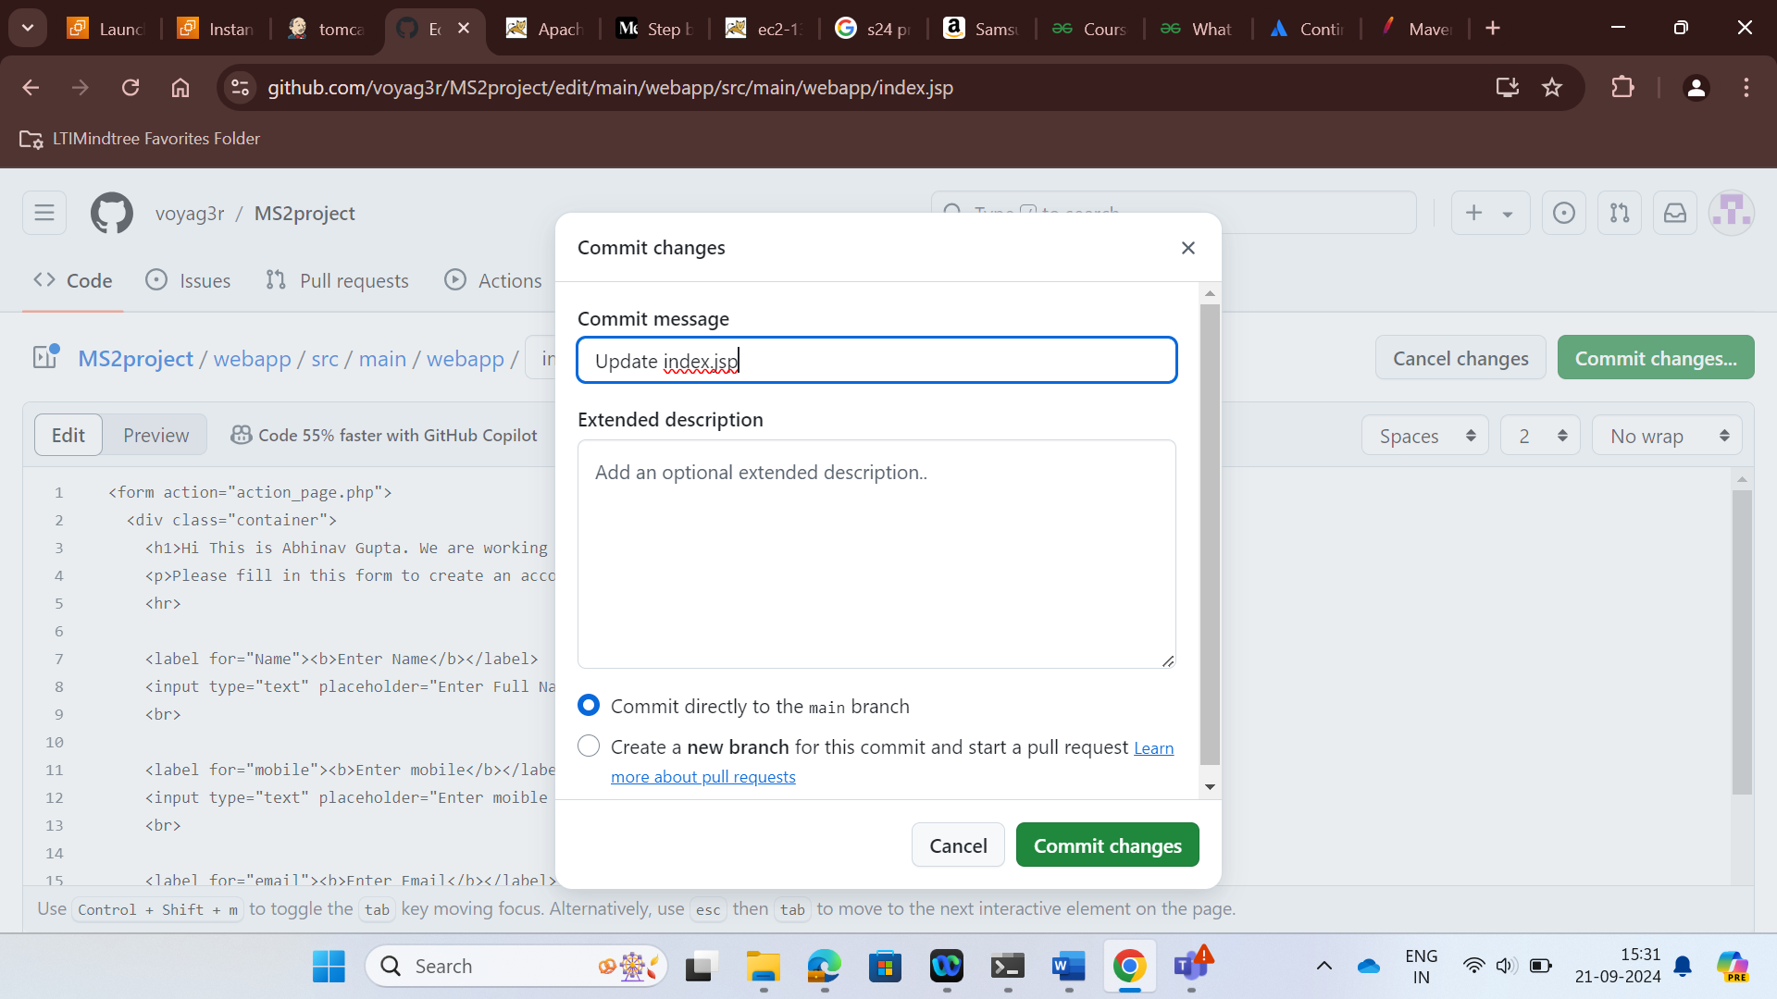

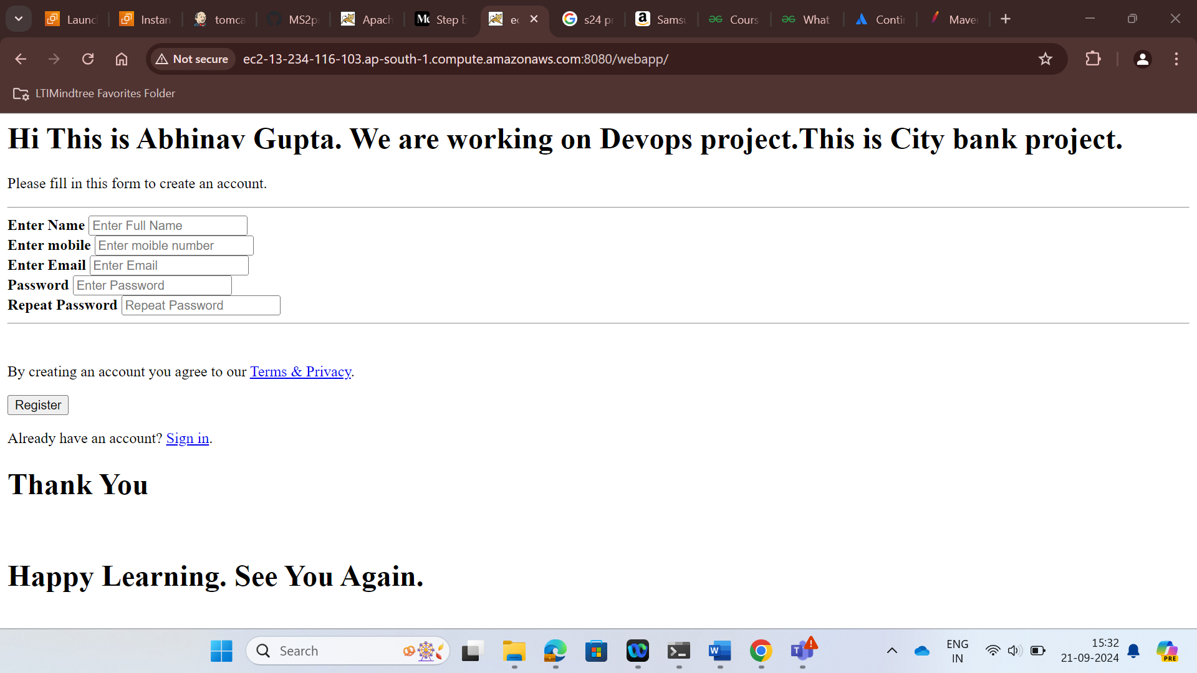

Here we can see successful integration.

STEP 2:

- Created an Docker instance

- Jenkins and Docker is connected to Jenkins SSH Server Via Public IP

- Docker is connected to Jenkins via Public Ip

- Docker image is generated

- To push the Docker image to Amazon ECR we are giving push commands in Jenkins which automatically push the docker image to ECR

Docker Server:

First install docker

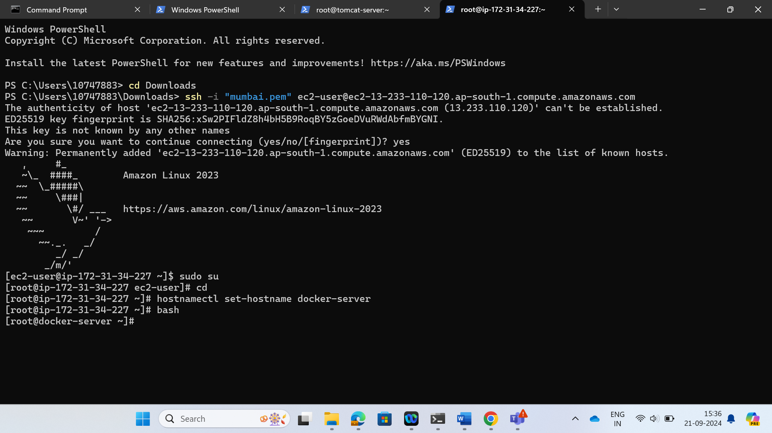

r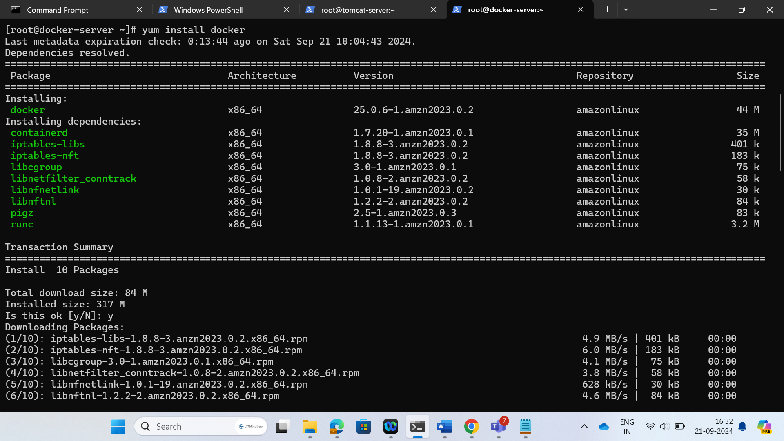

create sshkey

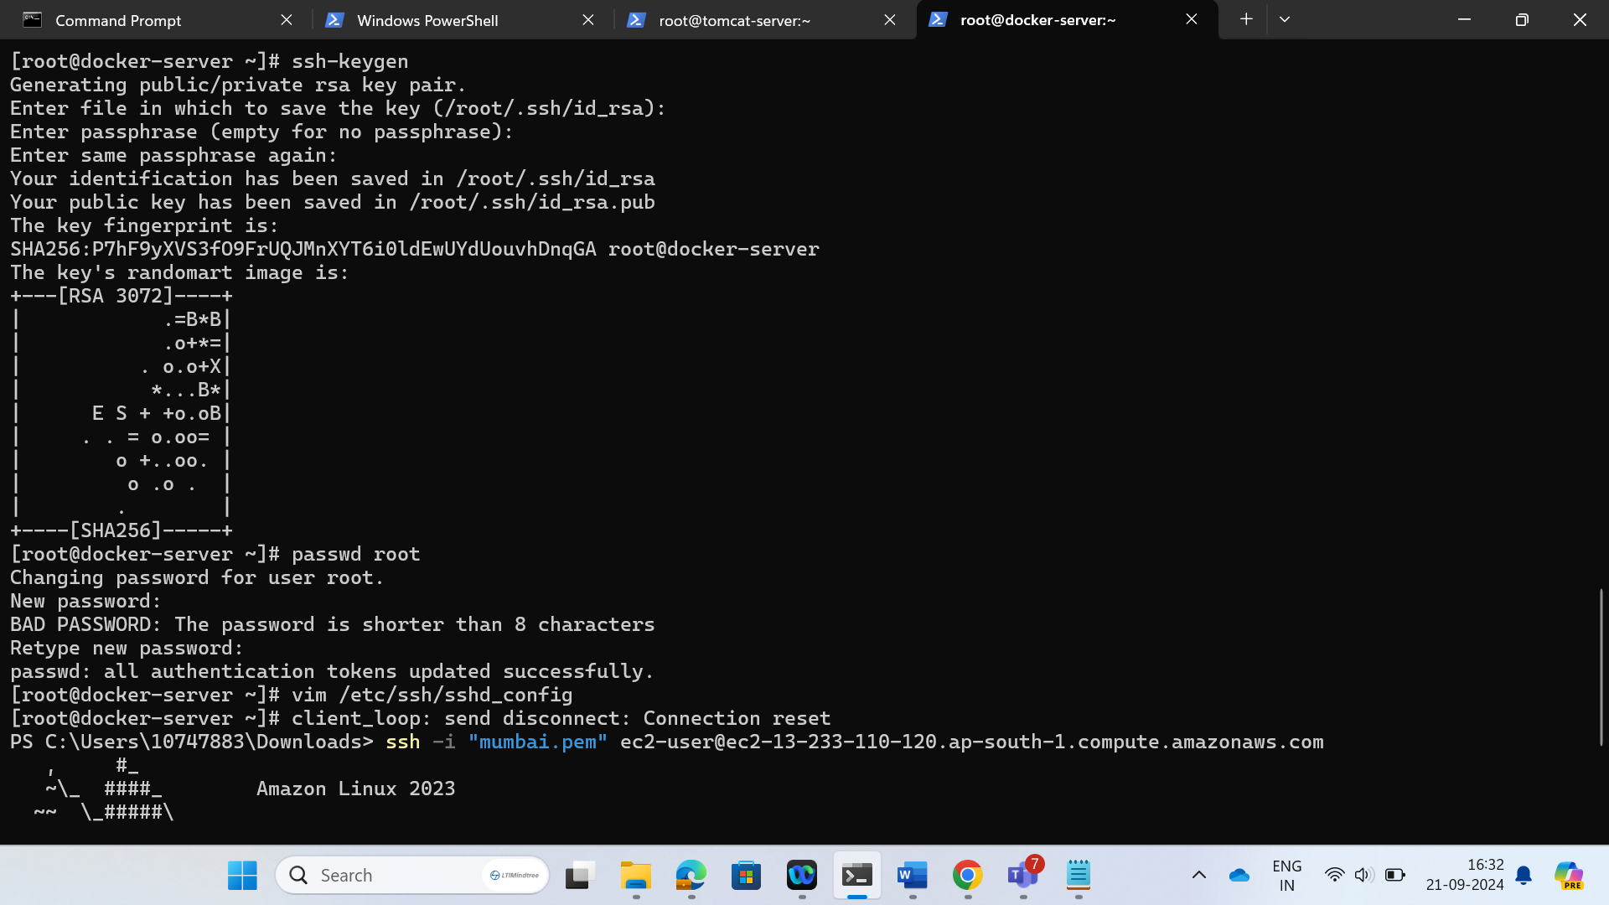

Exchange ssh keys between Jenkins and docker.

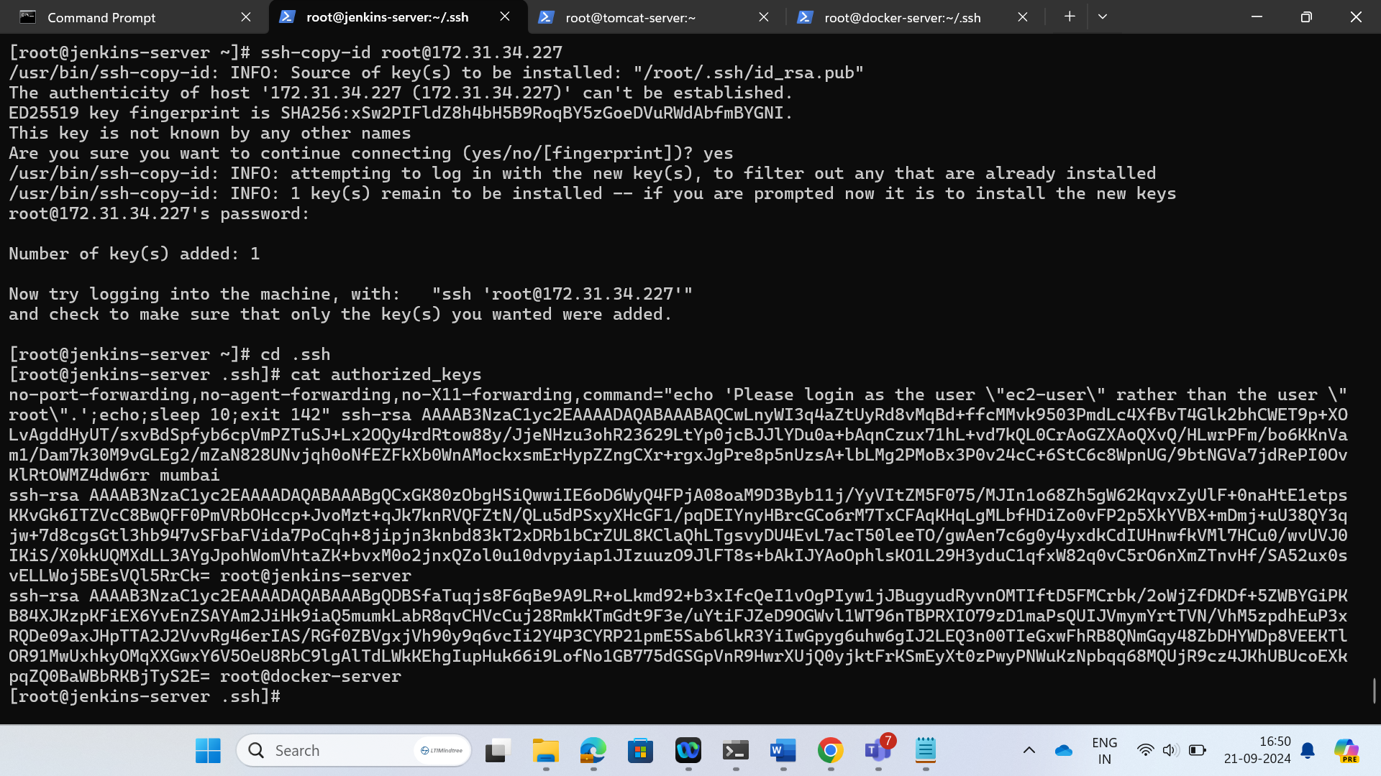

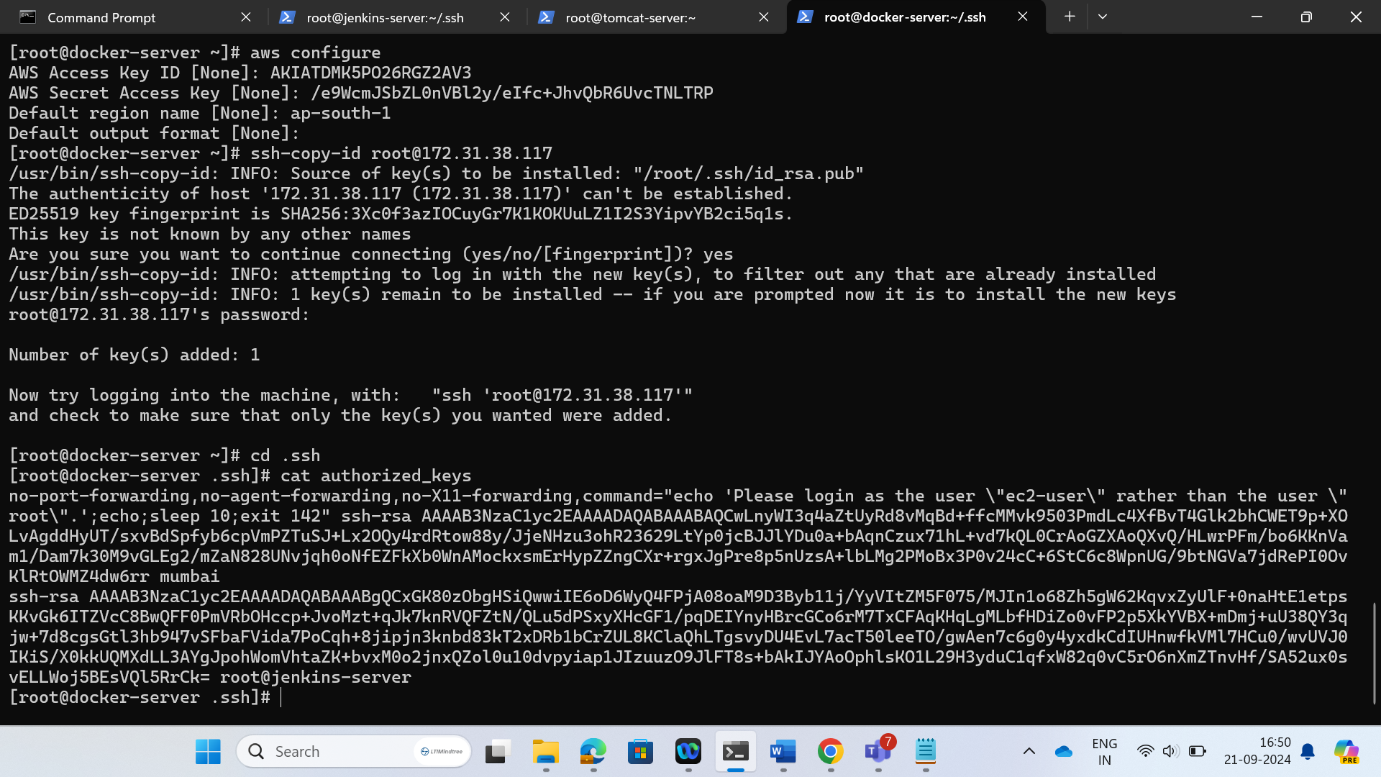

Update docker ip in ssh server.

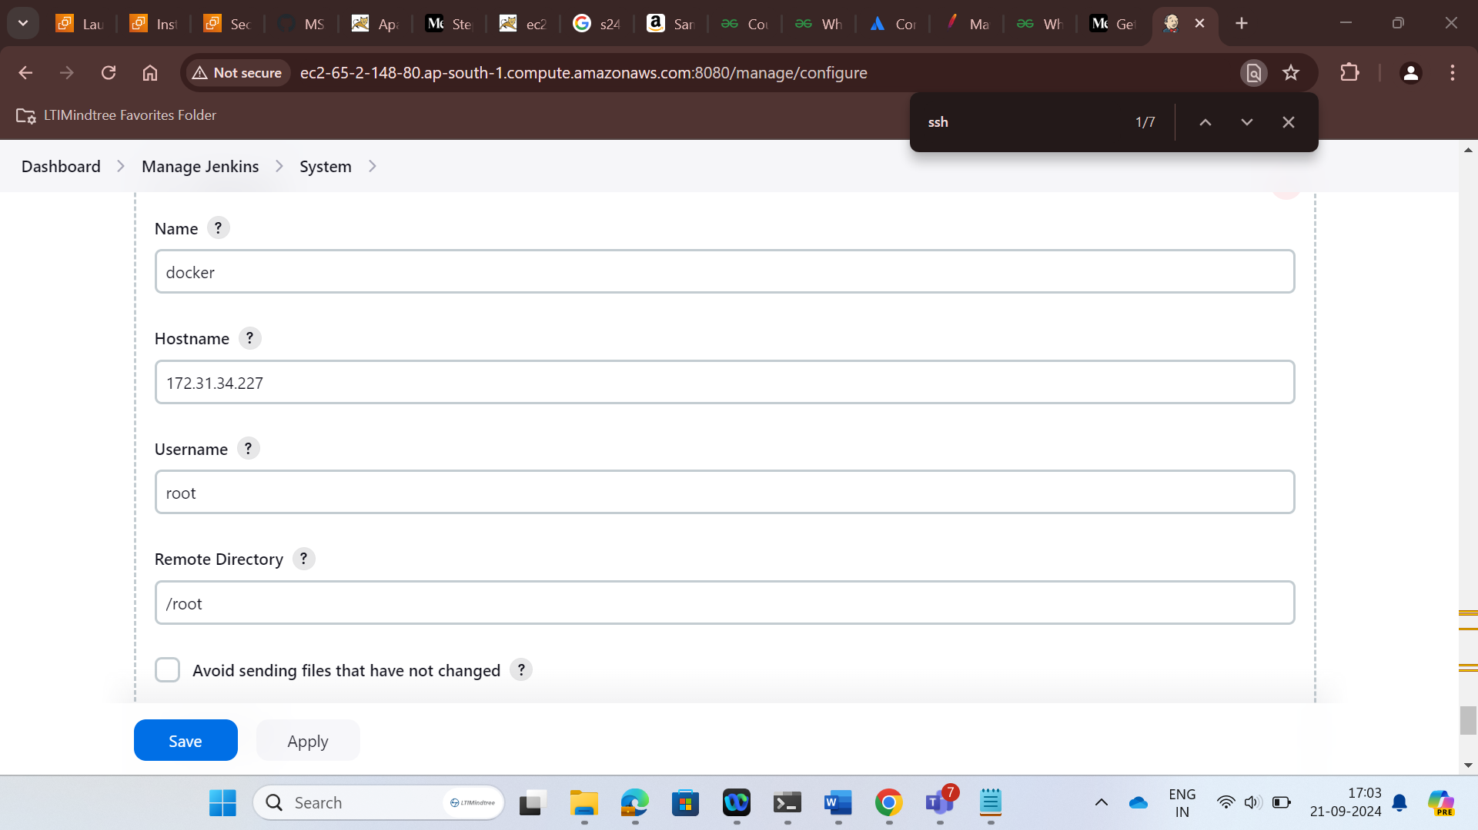

Check the build

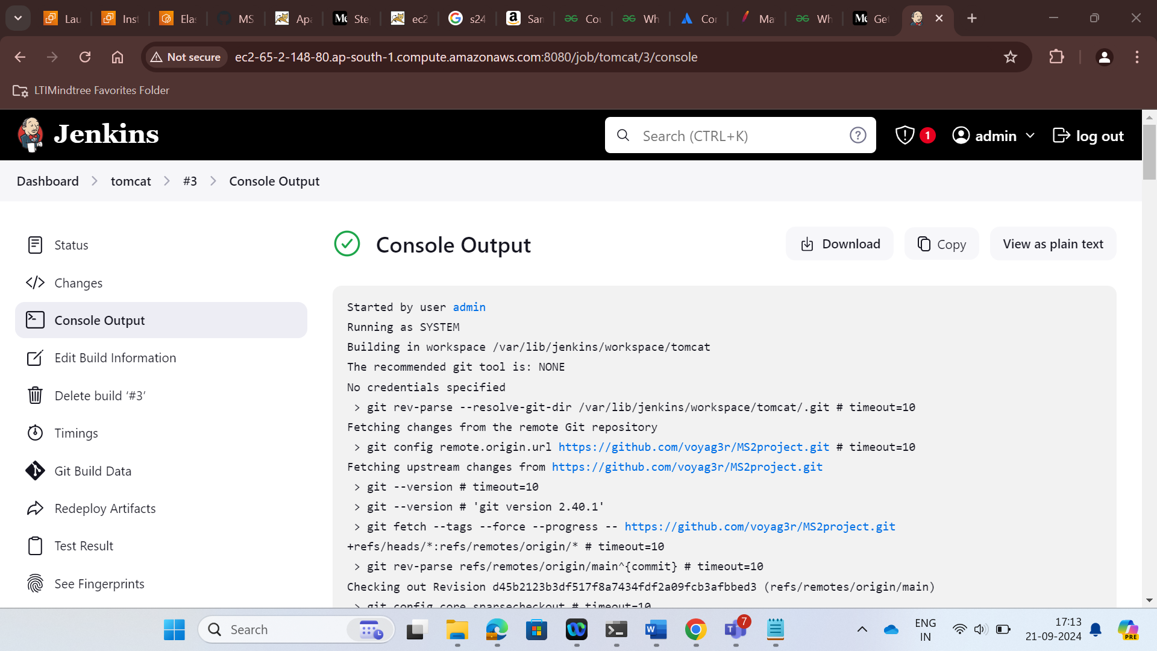

STEP 3:

- Here we created a new instance for Kubernetes

- Then we created SSH key in Kubernetes to connect with Docker via public key

- EKS Cluster is created to managed and monitor Docker image and deploy to web server

- Node groups are created manage the EKS cluster

- Deployment and Service file are created

- Kubernetes is configured with Jenkins via public ip of Kubernetes and deployment and service file creation command are fed into Jenkins which automatically does that job

- Now the server is accessible by image url on port 8080/webapp

EKS cluster:

Create EKS cluster then node groups

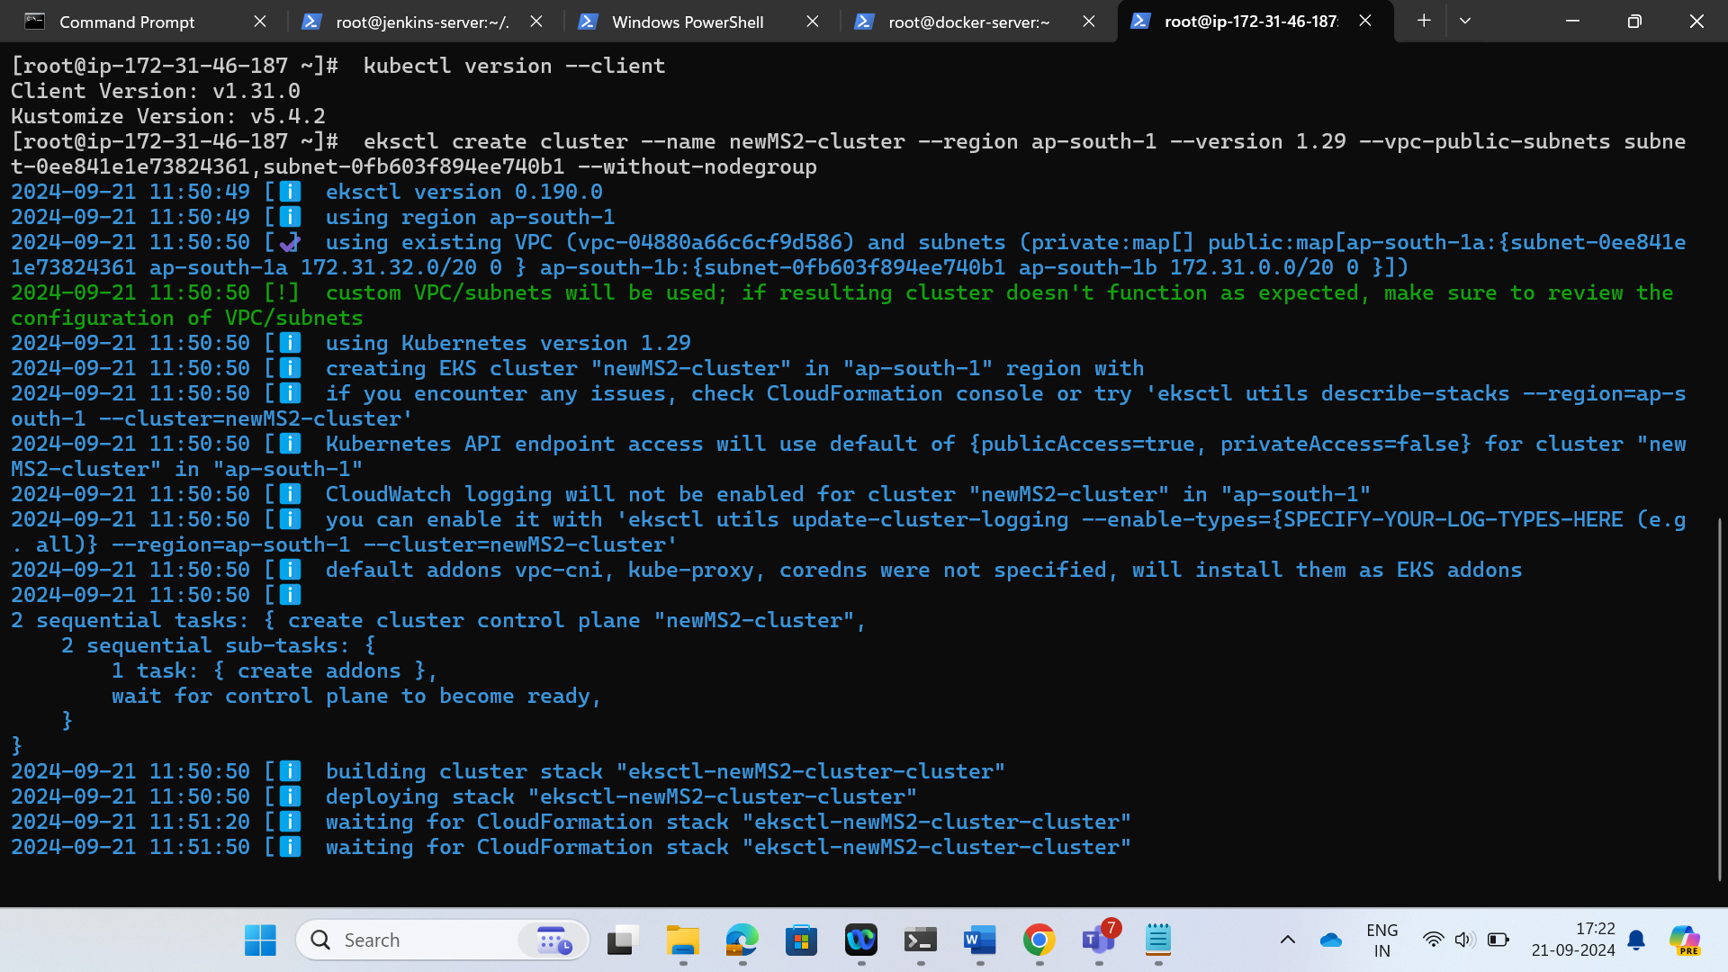

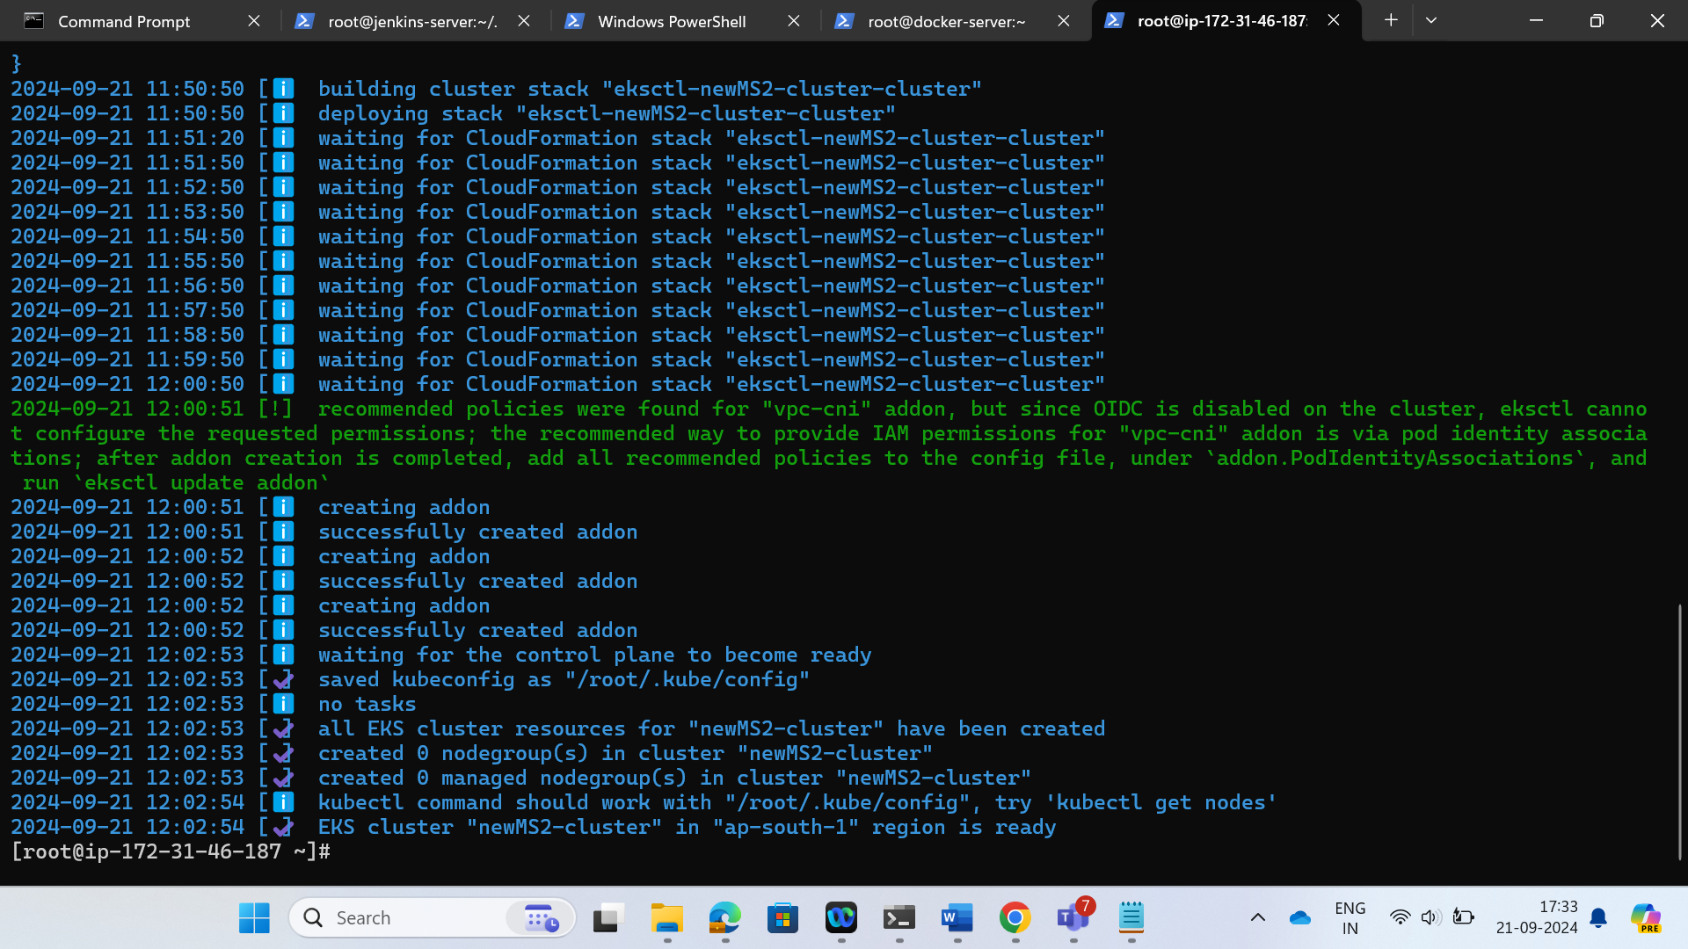

Create one deployment.yml file and service.yml file and paste image URL

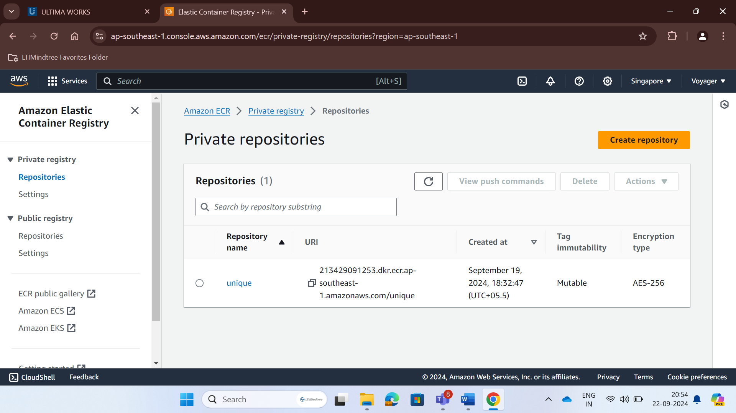

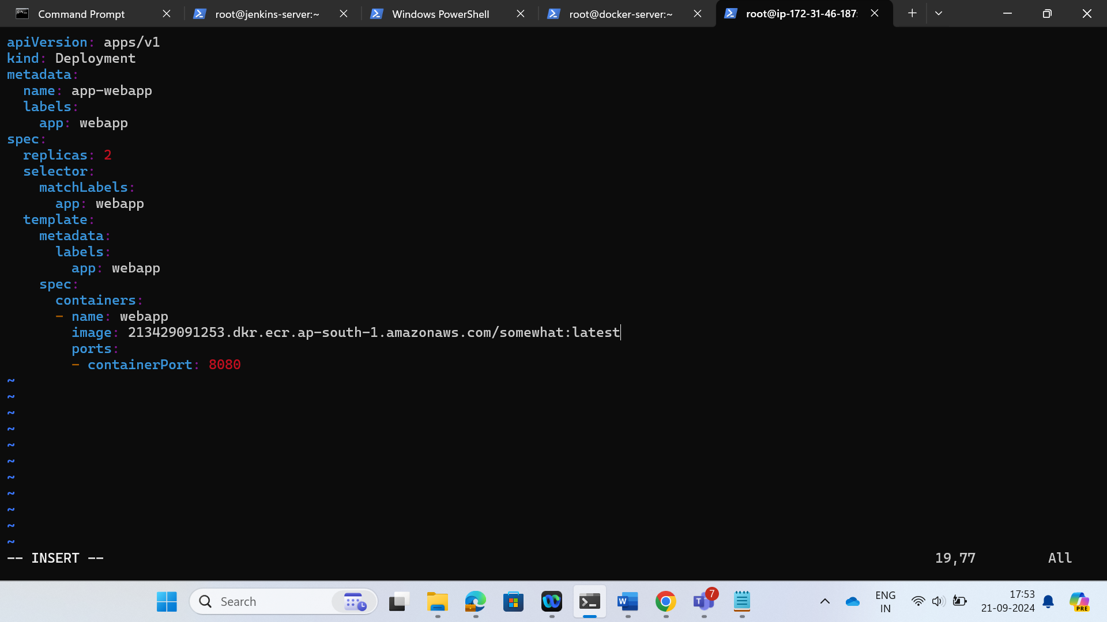

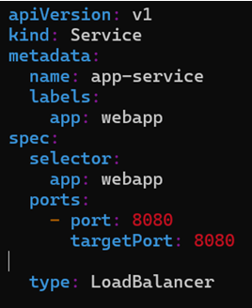

Update ssh server configuration in systems and see if it’s successful.

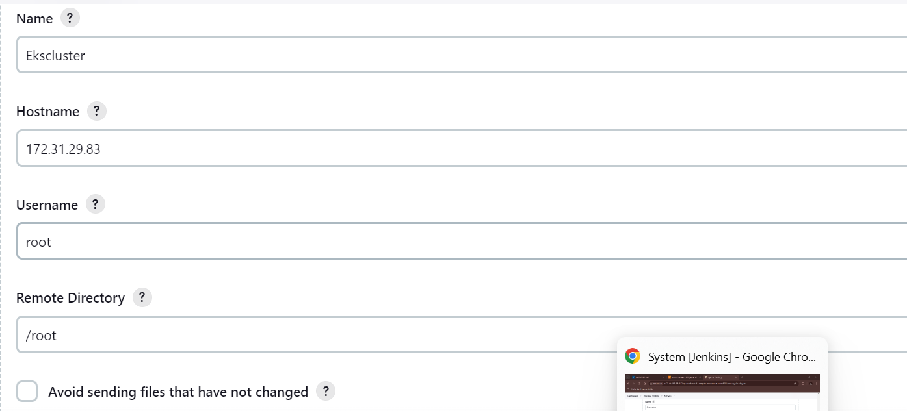

Now update project configuration to

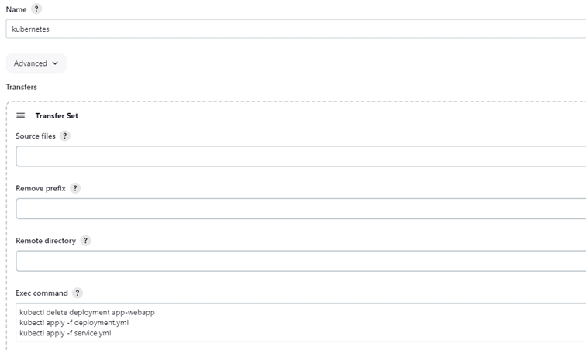

Use these commands to automatically deploy the instance

In the cluster server run kubectl get svc and paste the url



In this way we can use CI/CD to deploy our applications

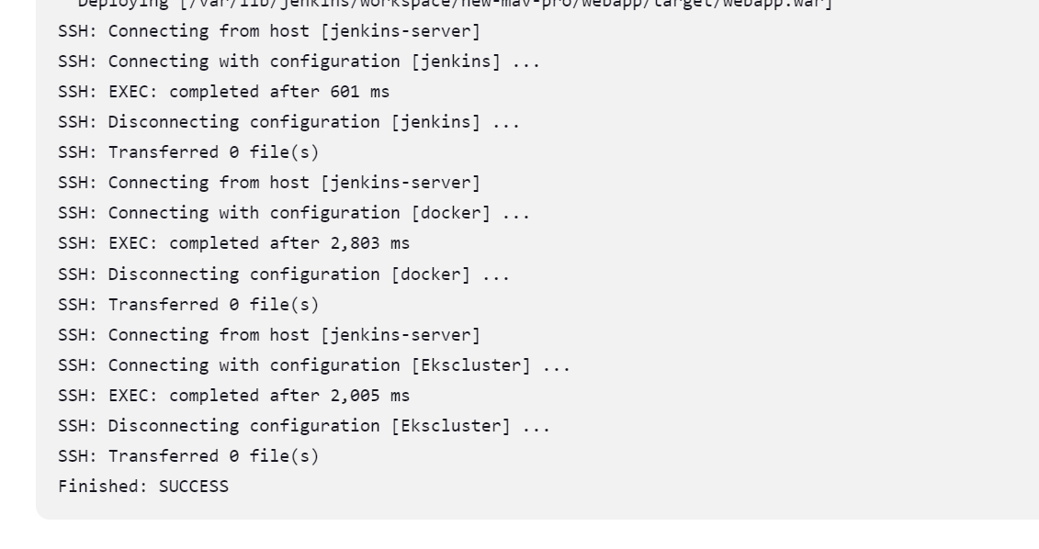

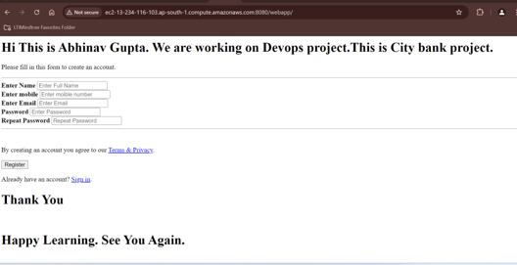

By Abhinav Gupta , 10747883